HW 01 textbook problems and hints
This document is intended to supplement, not replace, the actual assignment document. Read that one first. If there are discrepancies in point values or problems between this document and the assignment document, assume that the assignment document is correct, and tell me so I can fix this one. This notice applies to all of my “problems and hints” documents.
Section 1.1 (problem 1 – 5 points) Problem 12 [11 from 2nd edition]
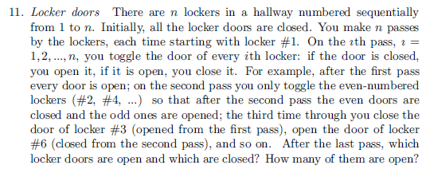
Author's Hint
1.2 (2 - 5) (four people and a flashlight)
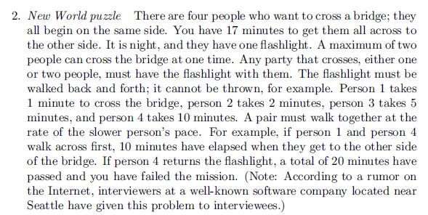
Author's Hint
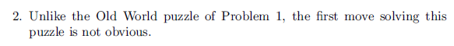
1.3 (3 - 5) (are n given points on circumference of the same circle?). Input: a list of coordinates, output: boolean.
You can be brief, but do not be so vague that I cannot tell whether you really know how to do this.
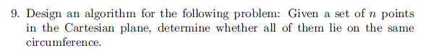
Author's Hint
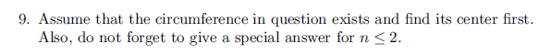
Instructor’s Clarification
Input: a list of coordinates
Output: boolean.
Your description can be brief, but not so vague that I cannot tell whether you really know how to do this.
1.4 (4 – 6, 5 – 5, 6 - 3)
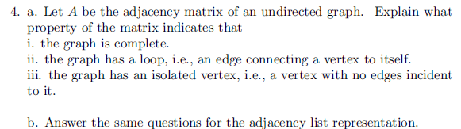
Author's Hint
Instructor note on problem 5 (1.4.4): ) The algorithm is given a reference to a node of the free tree. Assume that the free tree is represented as a graph with adjacency lists, and that each node of the rooted tree has a list of the nodes that are adjacent to it. The algorithm should return a reference to the root node of the rooted tree that it constructs.
The assignment document contains (at the very end of the document) an example.
Author's Hint
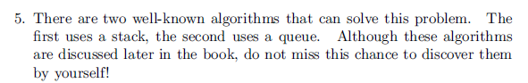
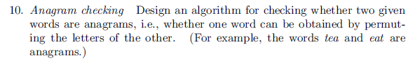
Author's Hint
Instructor's Note: Note that it says “anagram”, not “palindrome”.

Not from the textbook (7 – 5, 8 – 10)
- (5) ) (combinatorial practice, thanks to former RHIT faculty member Salman Azhar) .
This problem is partly an exercise in careful reading. It is a hard problem.
Each element of nonempty set A is a set of four distinct random digits; each digit is
in the range 1..9 (inclusive). Example: A = {{2, 4, 7, 5}, {1, 4, 8, 3}, {1, 3, 5, 9}}.
Construct set B from A as follows.
For each element of A (that element is a set of four single-digit numbers), we
construct the corresponding element of B as the sum of the 24 four-digit integers that
are all possible permutations of that element of A.
So if A is a set of k sets, B is a set of k numbers.
Find (and show how you get it) the smallest possible value of the GCD (greatest
common divisor) of all of the elements of B.
Note that the GCD of the elements in a particular set B depends on which sets are in
the particular A from which B is derived.
So we are looking for
min({gcd(B) : B is the set of the sums of all permutations associated
with each of 4-element sets in A}),
where the minimum is taken over all A’s which are nonempty sets of 4-element sets.
- (10) Read through the review of Mathematical induction that is linked from the
Resources column of Session 2 on the Schedule Page.
This is an enhanced composite of some materials that I used when we used to emphasize induction more in CSSE 230. Even if you already feel quite comfortable with both ordinary and strong induction, be sure to read the part on how not to do induction.
Other sources on induction: Weiss 7.2, Grimaldi Chapter 4.
Let the Fibonacci numbers be as defined on page 80 [78] of Levitin. On pages 80-82 [79-80], the author derives an explicit formula (2.9)[(2.11)] for the nth Fibonacci number. Another approach (the one Weiss uses) is to produce the formula "by magic" and use mathematical induction to prove it. That "proof by induction" approach is what you are to do for this problem. Be sure that in your induction proof you make it explicit what the induction hypothesis is and how it is used.

Hint: you might first want to prove (induction is not needed for this part) the simple relationship among 1, φ, and φ² , namely 1+ φ = φ², which implies the same relationship among φ^{k}, φ^{k+1}, and φ^{k+2}. Note that φ and φ̂ are defined on page 80 [80] of Levitin.

Note that this is essentially the same as Weiss problem 7.8, which I always assign when I teach CSSE 230.

