HW 09 textbook problems and hints
4.4 (1 – 5)
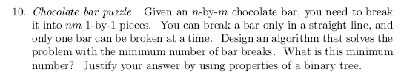
10. Breaking the chocolate bar can be represented by a binary tree.
5.3 (2 - 9)
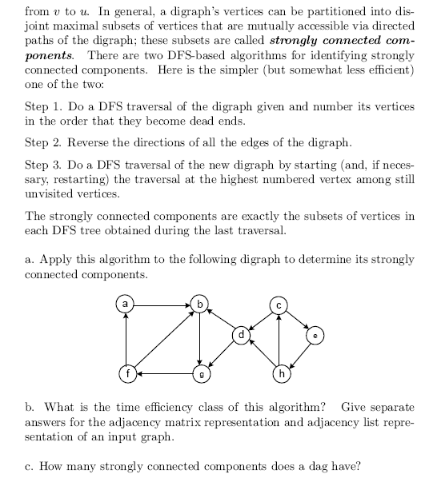
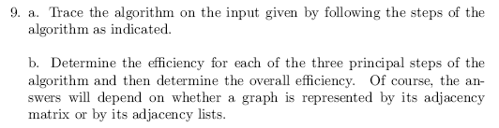
5.4 (3- 9, 4 - 5, 5 - 5)
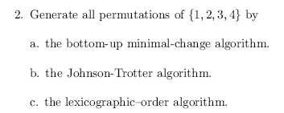
2. We traced the algorithms on smaller instances in the section.
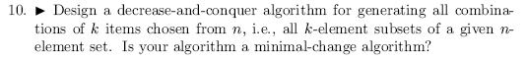
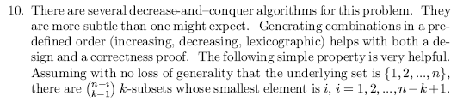
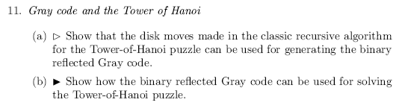
11. Represent the disk movements by flipping bits in a binary n-tuple.

5.5 (6 - 6)
