CSSE 473 HW #3 Levitin problems (3rd edition) from Section 3.1
The other problems that are not from the textbook are not listed in this document.
For these problems, assume that arithmetic operations are constant time.
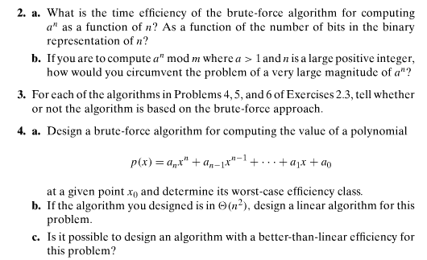
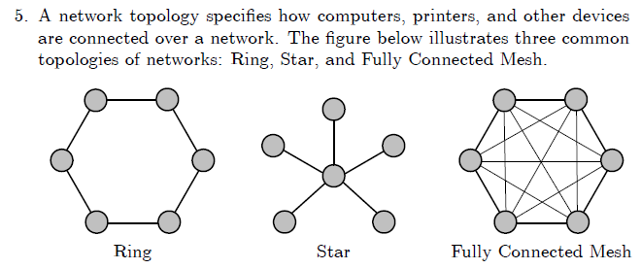
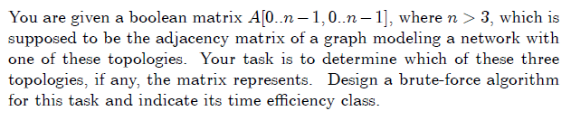
Note that it says “if any”, so “none of the above” is a possible answer.

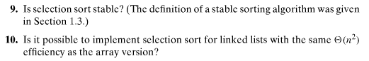
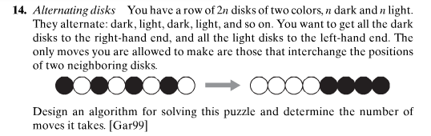

Author's hints on next page:

Author's hints: Section 3.1
