473 Levitin problems and hints HW 09

Problems 1 and 2 are not from the textbook.
Problem 3: 4.4.8 [5.5.2]
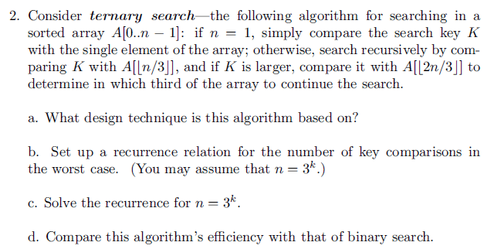
Author's Hints:
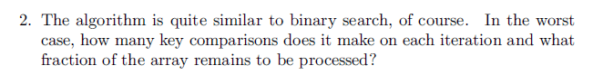

Problem 4: 4.4.10[5.5.3]
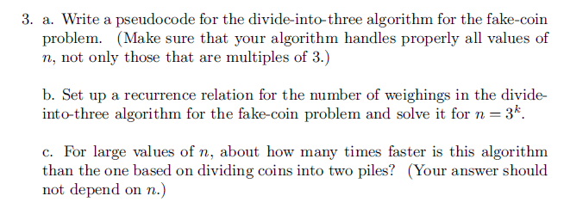
Author's Hints:
5.6.10: This problem may be harder than it looks at first. Perhaps it is no accident that the problem is in section 5.6, and also very close to Chapter 6.
"Transform and conquer" is a good way to find a complete solution. However, If you can't solve the general case, to get some partial credit solve some cases that you can solve, and talk about what you tried for other cases.

Problem 6: 4.5.11a[5.6.10a]
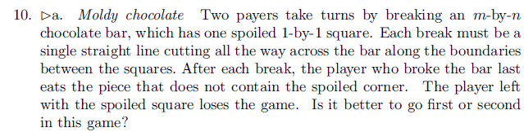
Author's Hints: 