473 Levitin problems and hints HW 08

Problem 1: (15) 5.3.8 [4.4.7]
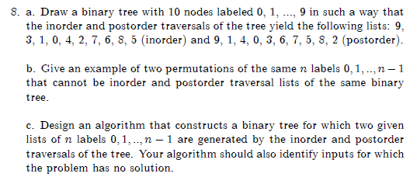
Author's Hints:
Problem 2: (5) 5.3.11 [4.4.10]
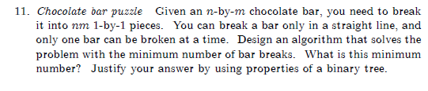
Author's Hints:

Problem 3: (5) 5.4.9 [4.5.9]
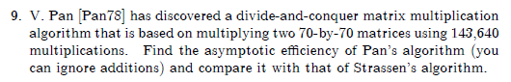
Author's Hints:
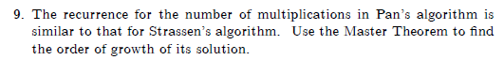

Problem 4: (10) 5.5.3 [4.6.2]
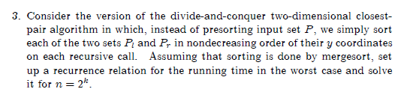
Author's Hints:
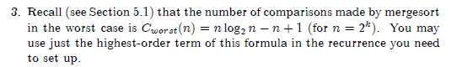

Problem 5: (5) 5.5.7 [4.6.6]
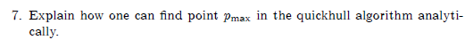
Author's Hints:
Problems 6-8: Not from textbook
- ( 5) Which permutation immediately follows 37246510 in lexicographic order?
Show how you use the algorithm from Day 18 class to get your answer.
- ( 5) If the permutations of the numbers 0-7 are numbered from 0 to 8!-1,
what is the (lexicographic ordering) sequence number of the permutation 37246510?
( 5) Which permutation of 01234567 is number 25000 in lexicographic order?

