MA/CSSE 473 HW 7 Problem statements/hints

Problems 1 and 2 (copied here from the assignment document):

- (15) (RSA decoding). If small primes are used, it is computationally easy to "crack" RSA codes.
Suppose my public key is N=703, e= 53. You intercept an encrypted message intended for me, and the encrypted message is 361. What was the original message? How did you get the answer?
- (6) (RSA attacks) Read about various ways of attacking the RSA cryptosystem.
Write about two attacks that interest you. Explain how they work.
Problem 3: (3) 5.1.4 [4.1.4] (logarithm base in Master theorem)
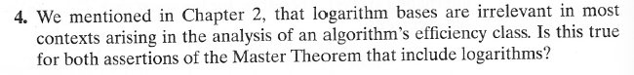
Problem 4: (6) 5.1.5 [4.1.5] (simple application of Master theorem)
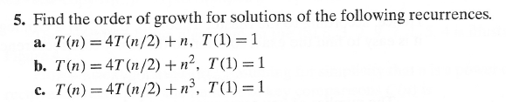
Author's hints for problems 3 and 4:
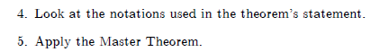
- Problem 5: (6) 5.2.2 [4.2.2] (Quicksort partition scan properties)
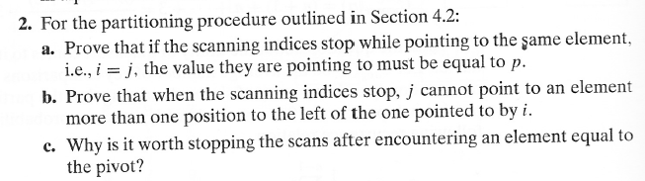
Author's hint for problem 5: Use the rules for stopping the scans.
Problem 6: (10)
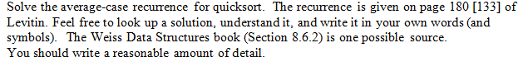Problem 7: (6)

Problem 7 5.2.8 [4.2.8] (Negatives before Positives)
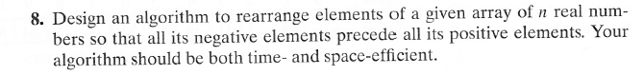
Author's hint for problem 8: Use the partition idea.
Problem 8: (8) 5.2.9 [4.2.9] (Dutch National Flag)
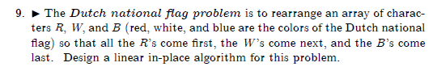
Author's Hints:
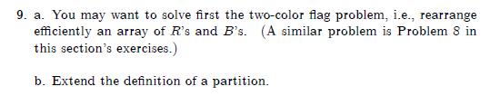

Problem 9: (8) 5.2.11 [4.2.11] (nuts and Bolts)
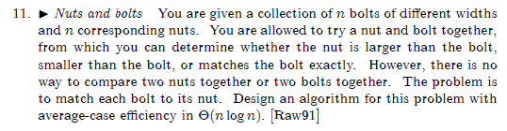
Author's Hints:
Use the partition idea.

