CSSE 473 HW #3 Levitin problems (3rd edition) from Section 3.1
The other problems that are not from the textbook are not listed here.
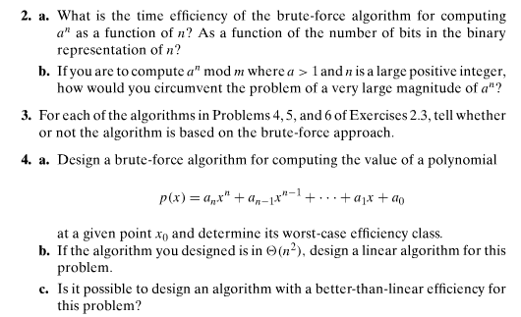
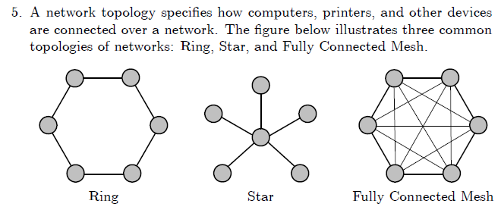
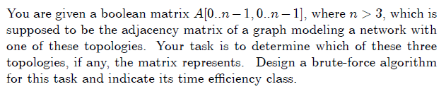

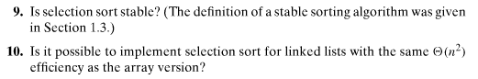
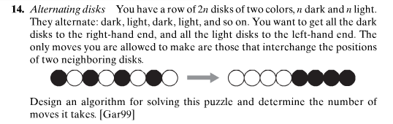

Author's hints on next page:

Author's hints: Section 3.1
