HW 01 textbook problems and hints
Section 1.1 (problem 1 – 5 points) Problem 12 (11 from 2nd edition)
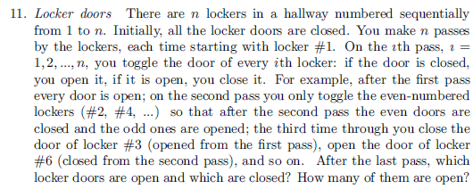
Author's Hint
1.2 (2 - 5) (four people and a flashlight)
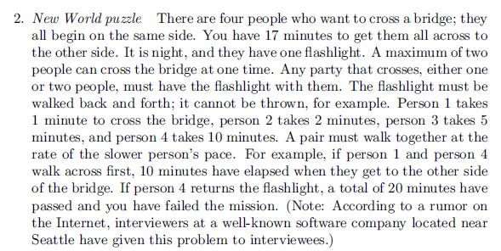
Author's Hint
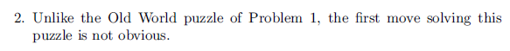

1.3 (3 - 5) (are n given points on circumference of the same circle?). Input: a list of coordinates, output: boolean.
You can be brief, but do not be so vague that I cannot tell whether you really know how to do this.

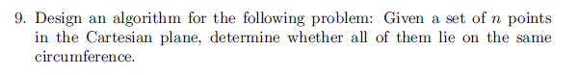
Author's Hint 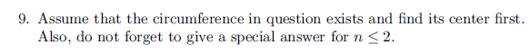

1.4 (4 – 6, 5 – 5, 6 - 3)
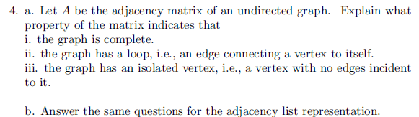
Author's Hint
Instructor note on problem 5 (1.4.4): ) The algorithm is given a reference to the free tree and a
reference to the node that is to be the root. Assume that the free tree is represented
As a graph with adjacency lists, and that each node of the rooted tree has a list of its
children.
Author's Hint
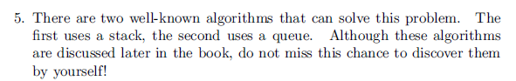
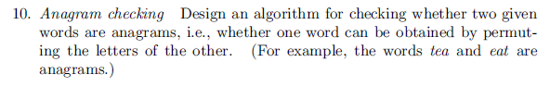
Author's Hint

Not from the textbook (7 – 5, 8 – 10)
- (5) (combinatorial practice, thanks to former RHIT faculty member Salman Azhar)
Each element of nonempty set A is a set of four distinct random digits, each digit in
range 1..9 (inclusive) 1 and 9. Example: A = {{2, 4, 7, 5}, {1, 4, 8, 3}, {1, 3, 5, 9}}.
Construct set B as follows. For each element of A, we construct a single element of
B as the sum of the 24 four-digit numbers that are all possible permutations of that
element of A. So if A is a set of k sets, B is a set of k numbers. What is the smallest
possible value of the GCD (greatest common divisor) of all of the elements of B?
Note that the GCD of the elements in B could possibly depend on which sets are in
the particular A from which B is derived.
- (10) Read through the review of Mathematical induction that is linked from the
Resources column of Session 2 on the Schedule Page.
This is an enhanced composite of some materials that I used when we used to emphasize induction more in CSSE 230. Even if you already feel quite comfortable with both ordinary and strong induction, be sure to read the part on how not to do induction.
Other sources on induction: Weiss 7.2, Grimaldi Chapter 4.
Let the Fibonacci numbers be as defined on page 80 [78] of Levitin. On pages 80-82 [79-80], the author derives an explicit formula (2.9)[(2.11)] for the nth Fibonacci number. Another approach (the one Weiss uses) is to produce the formula "by magic" and use mathematical induction to prove it. That "proof by induction" approach is what you are to do for this problem. Be sure that in your induction proof you make it explicit what the induction hypothesis is and how it is used.

Hint: you might first want to prove (induction is not needed for this part) the simple relationship among 1, φ, and φ² , namely 1+ φ = φ², which implies the same relationship among φ^{k}, φ^{k+1}, and φ^{k+2}. Note that φ and φ̂ are defined on page 80 [80] of Levitin.

