HW 02 textbook problems and hints
Section 2.1 (Problem 1 – 6 points, 2 - 6)
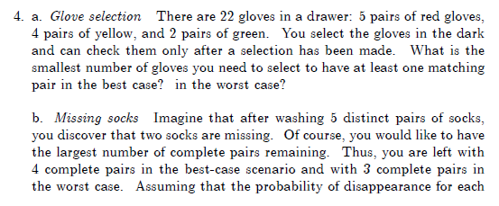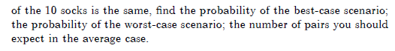
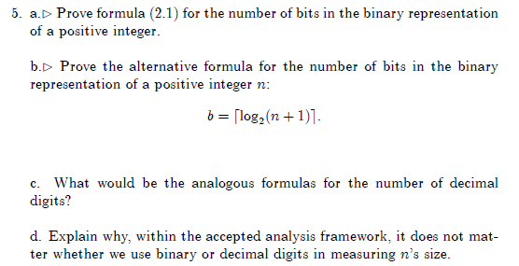
HINTS from the textbook (problems 1 and 2):
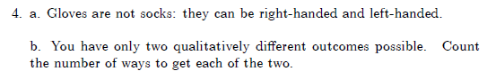
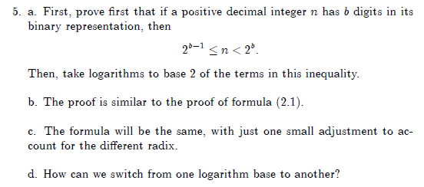

2.2 (3 – 10, 7 – 4 (parts a and d only), 12 -- 6)
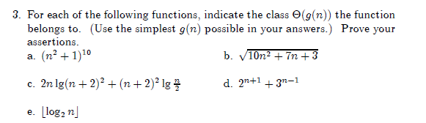
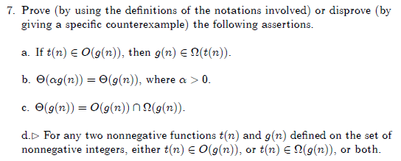
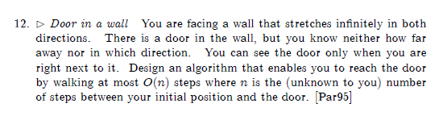

HINTS from the textbook (problems 3, 4, and 5):
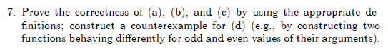
2.3 (6 – 8, 7 - 10)

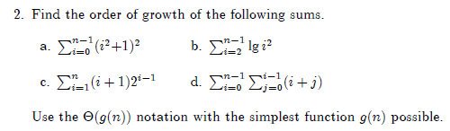
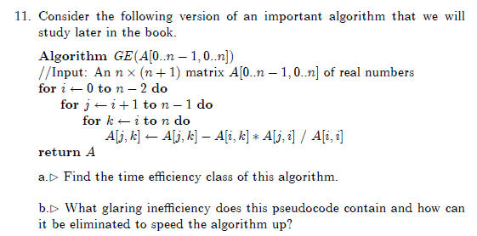
Include a quantitative indication of how much time is gained by removing the glaring
inefficiency.
HINTS from the textbook (problems 6 and 7):
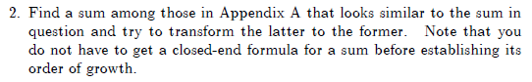
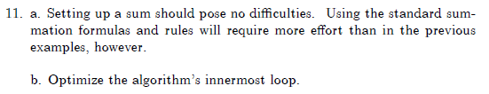

Problem 8: (10) 2.4.14 [ 5.3.10] Celebrity identification

HINTS from the textbook (problem 8):
Instructor clarification:
be sure to start this one early! "Efficient" in this case means making the number of questions for N people as small as you can, and you should say how many questions are required by your approach in the worst case.

The remaining problems are not from the textbook; t heir statements are directly in the assignment document.
- Master Theorem Proof (8 points).
These questions refer to the proof in Weiss section 7.5.3 ( available on ANGEL).
(a) (5 points) (7.11) Why is it O(A^{M})? Why is the second equation true (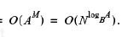)?
(b) (3 points) Sentence after (7.11). Why does the sum contain that many terms? Why does A = B^{k} imply A^{M} = N^{k}?
- Dasgupta questions (6 points, 2 for each part)
(a) What does Dasgupta say are the two main ideas that changed the world? Do you agree? What else might you include in the list?
(b)Why is the simple algorithm at the bottom of page 4 actually not O(n)?
(c) Show how to use al-Khwarizmi's technique to multiply 9 (first column) by 15 (second column).

