MA/CSSE 473 HW 13 textbook problems and hints
Problem #1 (10) 9.1.3 (Greedy job scheduling)
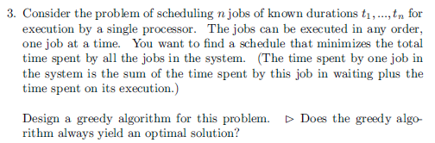
Author's hint:
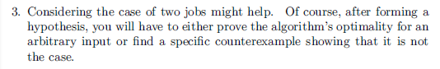
Problem #2 ( 6) 9.1.9b [9.1.7]b (Prim example)
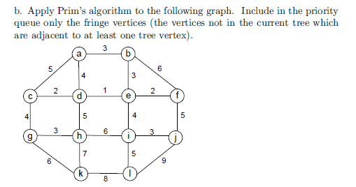
Author's hint:
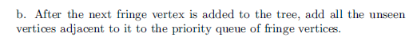

Problem #3 ( 5) 9.1.10 [9.1.8] (Prim prior connectivity check?)
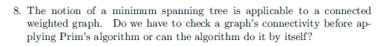
Author's hint:
Problem #4 (10) ) 9.1.15 [9.1.11] (change value of an item in a min-heap)
Author's hint
: 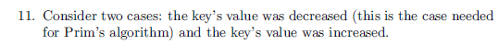
Problem #5 ( 6) 9.2.1b (Krushkal example)
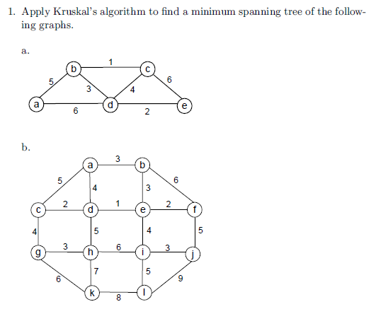

Author's hint:
Problem #6 ( 8) 9.2.2 (Kruskal TF questions) Briefly explain your answers.
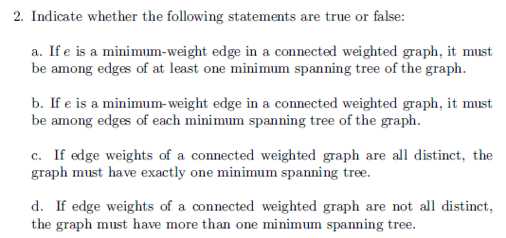
Author's hint:
Problem #7 (5) 9.2.8 (efficiency of find in union-by-size)
Author's hint:
Problem #8 ( 8) 9.4.1 Huffman Code construction
(a) 4 points. When there is a choice due to a tie, place the one that appears first in the problem
statement’s character list “on the left” in the tree. (b) 2 points. (c) 2 points.
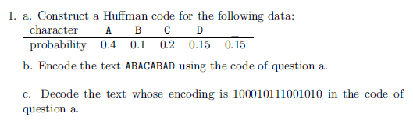
Author's hint:

Problem #9 ( 12) 9.4.3 Huffman TF Explain your answers
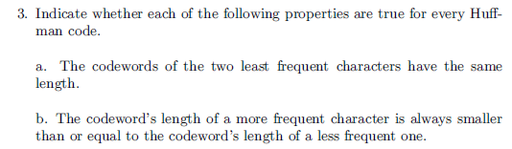
Author's hint:
