473 Levitin problems and hints HW 06

Problem 1: (6) 3.5.3 [5.2.3] Independence of properties from specific DFS traversals. Explain your answers.
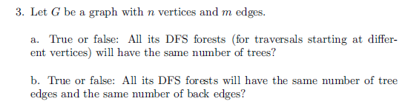
Author's Hints:
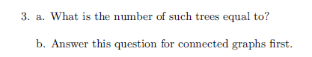

Problem 2: (10) 3.5.8a [5.2.8a] Bipartite graph checking using DFS
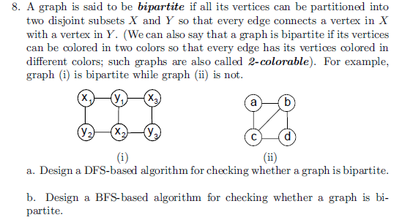
Author's Hints:
Problem 3: (5) 4.1.1 [5.1.1] Ferrying Soldiers
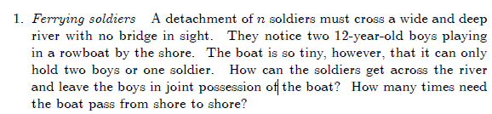
Author's Hints:
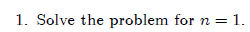
Problem 4: (5) 4.1.4 [5.1.3] generate power set
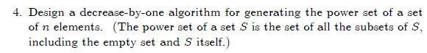
Author's Hints:

Problem 5: (5) (not in book) [5.1.9] binary insertion sort efficiency
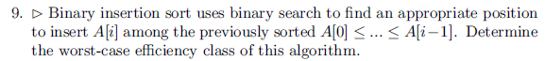
Author's Hints:
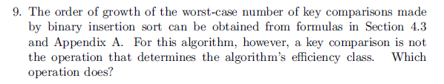
In the 3rd edition, it says "Prove that a nonempty dag must have at least one source." That additional word is necessary!
Problems 6: (9) 4.2.6 [5.3.6] dag source
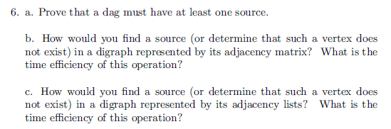
Author's Hints:
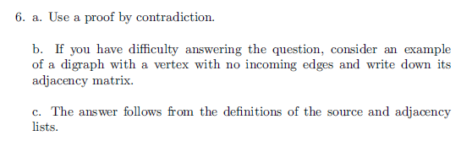

Problem 7: (9) 4.2.9 [5.3.9] Strongly connected components of a digraph
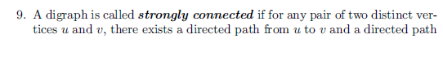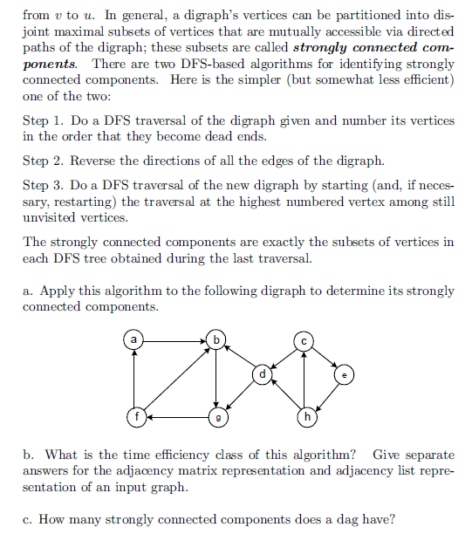
Author's Hints:
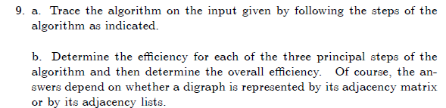

Problem 8: (15) Not in book
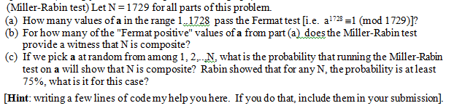

Problem 9: (9) 4.3.2 [ 5.4.2] Examples of permutation generation algorithms
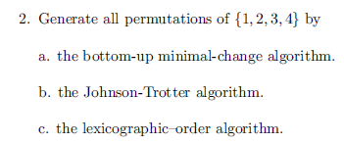
You do not have to write any code, but you can do it that way if you wish.
Author's Hints:
Problem 10: (10) 4.3.10 [ 5.4.10] Generation of all k-combinations from an n-element set
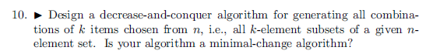

Author's Hints:
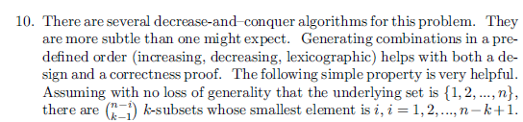

Problem 11: (10) 4.3.11 [ 5.4.11]
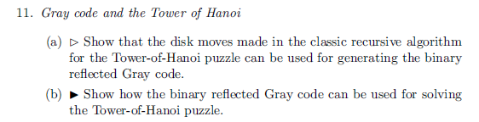
Author's Hints:

