CSSE 473 HW #3 Levitin problems (3rd edition) from Section 3.1. The other problems are not from the textbook.
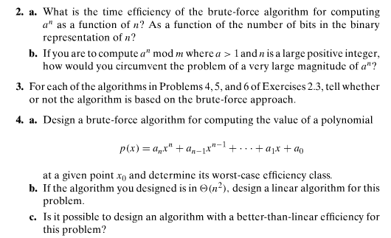
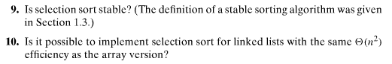
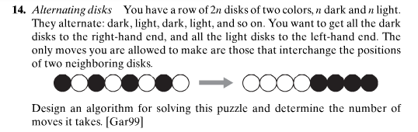

Author's hints on next page:

Author's hints: Section 3.1
