MA/CSSE 473 HW 16 textbook problems and hints
Problem #1 ( 5) 12.1.5 [12.1.4] (Hamiltonian circuit backtracking) Show the state space. 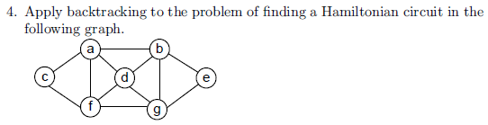 .
Author's hint:
Problem #2 ( 5) 12.2.1 (data structure for best-first branch-and-bound)
Author's hint:
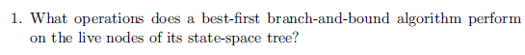
Problem #3 ( 5) 12.2.5 (use branch-and-bound to solve instance of knapsack problem) 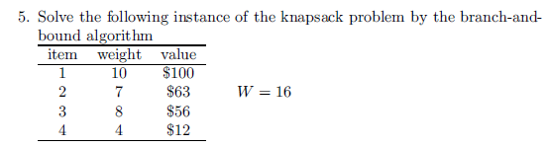
Author's hint:

Problem #4 (10) 12.3.1 (nearest-neighbor algorithm example) (4, 6))
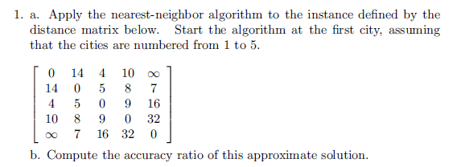
Author's hint
: 