MA/CSSE 473 HW 15 textbook problems and hints August 4, 2011
Problem #1 (5) 11.1.1 (lower bound for alternating disk algorithm) 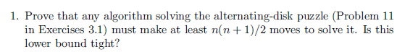 .
Author's hint:
Problem #2 ( 5) 11.1.4 (fake coin minimum number of guesses)
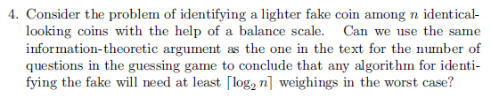
Author's hint:
Problem #3 (12) 11.1.10 (matrix multiplication and squaring) (6, 6)
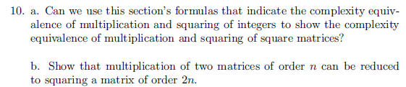
Author's hint:
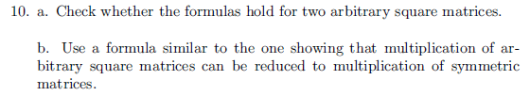

Problem #4 ( 9) 11.2.10ab [11.2.8ab] (advanced fake-coin problem) (4, 5) 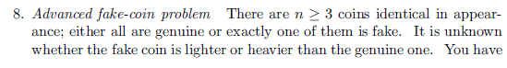
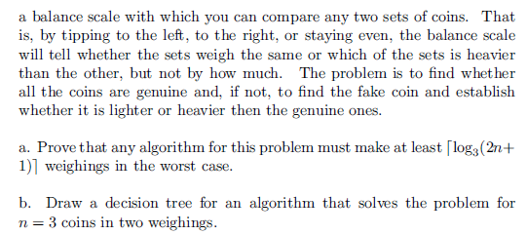
Author's hint
: 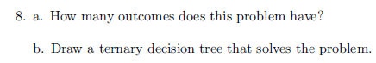
Problem #5 ( 5) 11.3.1 (Chess decidable?) Explain your answer.
. 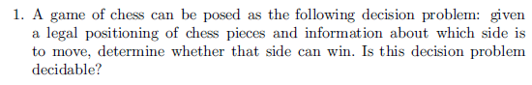
Author's hint:
Problem #6 ( 8) 11.3.2 (tractable?) Explain your answer.
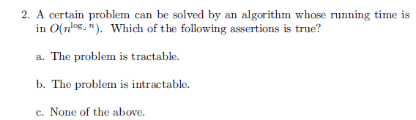
Author's hint:

Problem #7 ( 5) 11.3.6 (brute force composite number)
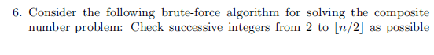
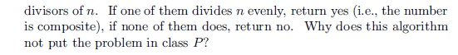
Author's hint:
Problem #8 ( 5) 11.3.7a (polynomial –time check of knapsack solution)
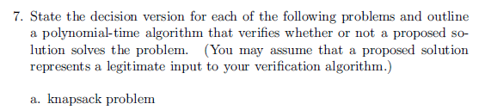
Author's hint:
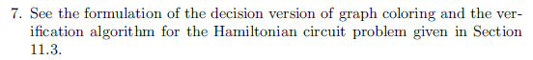
Problem #9 (5) 11.3.11 [11.3.10] (Venn diagrams)
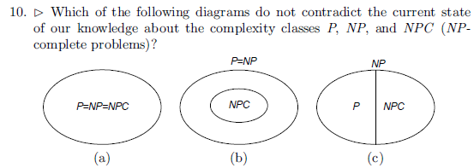
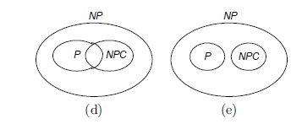
Author's hint:

Problem #10 (10) 11.3.12 [11.3.11] (King Arthur problem) Optional, extra-credit problem
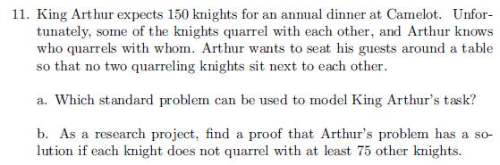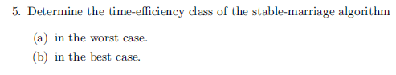
Author's hint:

