HW 12 textbook problems and hints
Problem 1. 8.4.3 [8.2.3] (5) (Warshall with no extra memory use)

Problem 2. 8.2.4 (10) (More efficient Warshall inner loop)
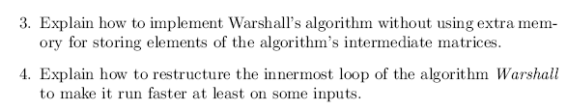
Author's hints:
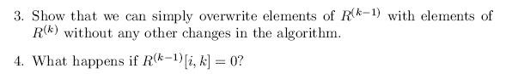

Problem 3. OptimalBST problem (25 points plus extra credit) ,
description is in the assignment document
Problem 4. 8.3.3 (10) (Optimal BST from root table)
Author's hint:
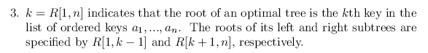

Problem 5. 8.3.4 (5) (Sum for optimalBST in constant time)
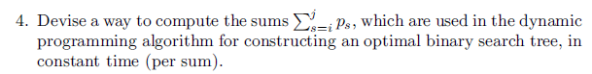
Author's hint
: 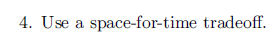

Problem 6. 8.3.6 (10) (optimalBST--successful search only--if all probabilities equal)
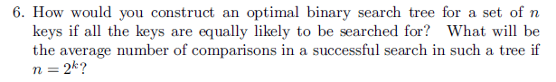
Author's hint:
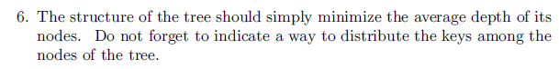

Problem 7. 8.3.10a (5) (Matrix chain multiplication)
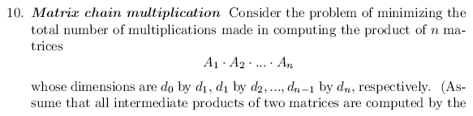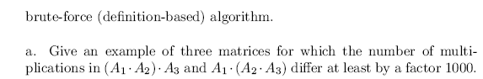
Author's hint:
