HW 10 textbook problems and hints
- Problem 6.1.5 [6.1.7] (10)
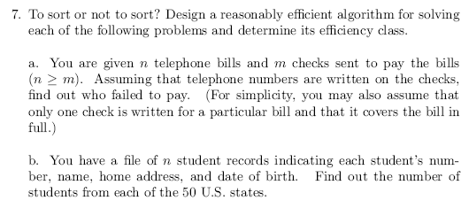
Author's hint:
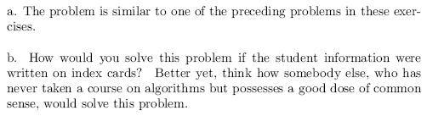
Problem 2: 6.28c ( 10)
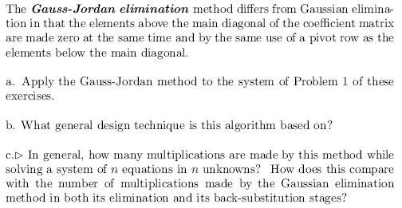
Students are only required to do part c. I put the rest here for context.

Author's hint:
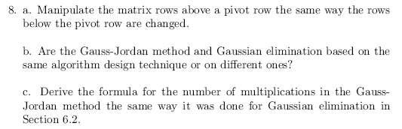
Problem 3 6.3.7 (6)
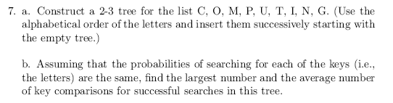
Author's hint:
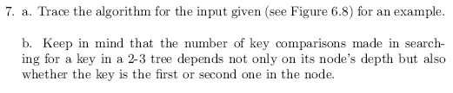
Problem 4 (20) not from textbook
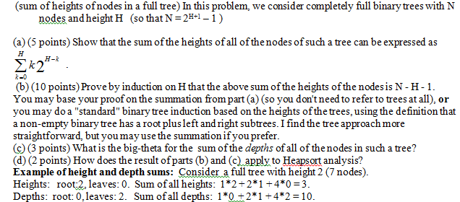
Problem 5 6.4.12 [6.4.11] (10)
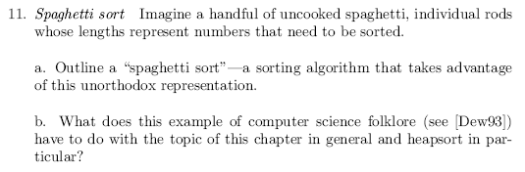
Author's hint:
Problem 6 6.5.10 [6.5.9] (3)
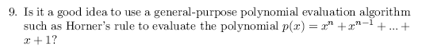
Author's hint:
Problem 7 7.1.6 (10)
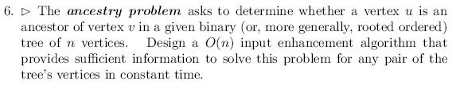
Author's hint:
Instructor notes
