473 Levitin problems and hints HW 09

Problem 1: 4.4.8 [5.5.2]
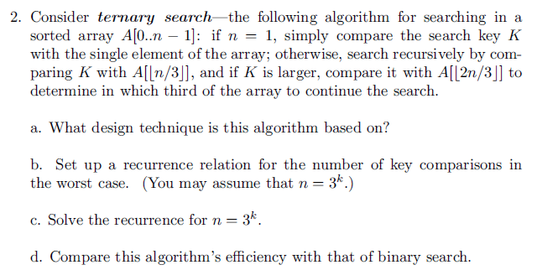
Author's Hints:
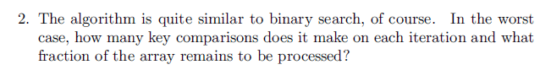

Problem 2: 4.4.10[5.5.3]
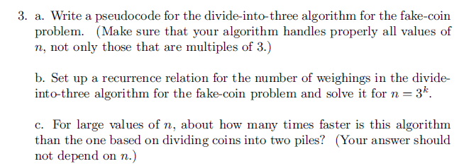
Author's Hints:
Problems 3-5: Not from textbook
- ( 5) Which permutation immediately follows 37246510 in lexicographic order?
Show how you use the algorithm from Day 18 class to get your answer.
- ( 5) If the permutations of the numbers 0-7 are numbered from 0 to 8!-1,
what is the (lexicographic ordering) sequence number of the permutation 37246510?
5.6.10: This problem may be harder than it looks at first. Perhaps it is no accident that the problem is in section 5.6, and also very close to Chapter 6.
"Transform and conquer" is a good way to find a complete solution. However, If you can't solve the general case, to get some partial credit solve some cases that you can solve, and talk about what you tried for other cases.

- ( 5) Which permutation of 01234567 is number 25000 in lexicographic order?
Problem 6: 4.5.11a[5.6.10a]
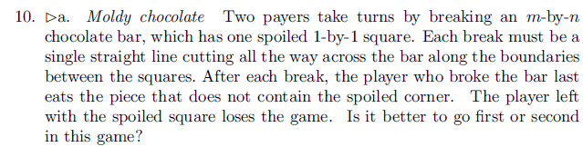
Author's Hints: 