473 Levitin problems and hints HW 08

Problem 1: (8) 5.2.9 [4.2.9]
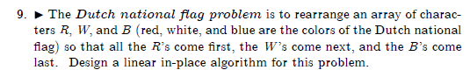
Author's Hints:
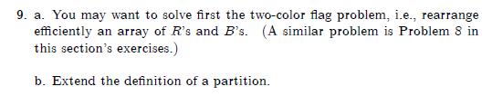

Problem 2: (8) 5.2.11 [4.2.11]
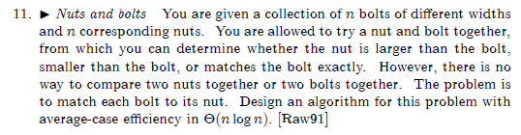
Author's Hints:
Use the partition idea.
Problems 3: (15) 5.3.8 [4.4.7]
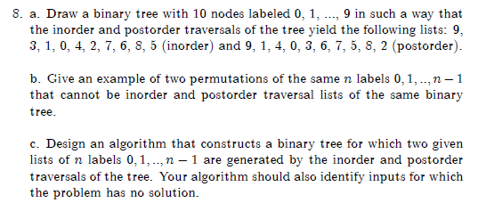
Author's Hints:
Problem 4: (5) 5.3.11 [4.4.10]
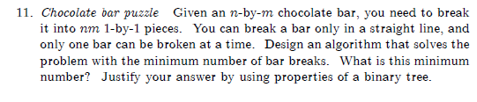
Author's Hints:

Problem 5: (5) 5.4.9 [4.5.9]
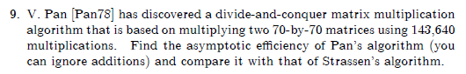
Author's Hints:
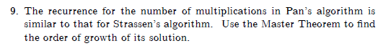

Problem 6: (10) 5.5.3 [4.6.2]
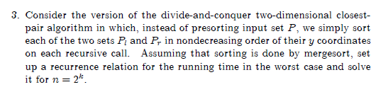
Author's Hints:
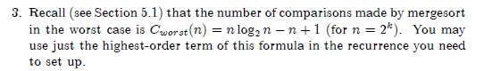
Problem 7: (5) 5.5.7 [4.6.6]
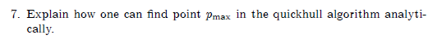
Author's Hints:

