MA/CSSE 473 HW 7 Problem statements/hints

Problems 1 through 3 (copied here from the assignment document):
- (15) (Miller-Rabin test) Let N = 1729.
- How many values of a in the range 1..1728 pass the Fermat test [i.e. a¹⁷²⁸ ≡1 (mod 1729)]?
- For how many of those values does the Miller-Rabin test provide a witness that N is composite?
- For N=1729, if we pick a at random, what is the probability that running the test on a will show that N is composite? Note: Rabin showed that for any N, the probability is at least 75%, what is it for this case?
[Hint: writing a few lines of code my help you here].
- (15) (RSA decoding). If small primes are used, it is computationally easy to "crack" RSA codes.
Suppose my public key is N=703, e= 53. You intercept an encrypted message intended for me, and the encrypted message is 361. What was the original message? How did you get the answer?
- (6) (RSA attacks) Read about various ways of attacking the RSA cryptosystem.
Write about two attacks that interest you. Explain how they work.
Problem 4: (3) 5.1.4 [4.1.4]
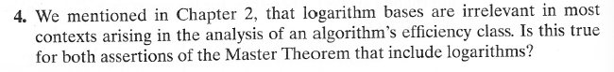
Problem 5: (6) 5.1.5 [4.1.5]
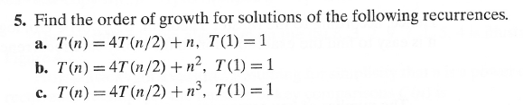
Author's hints for problems 4 and 5:
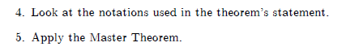
Problem 6: (6) 5.2.2 [4.2.2]
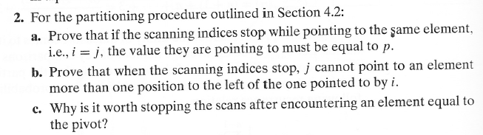
Author's hint for problem 6: Use the rules for stopping the scans.
Problem 7: (10)
- Solve the average-case recurrence for quicksort. The recurrence is given on page 180 [133] of Levitin. Feel free to look up a solution, understand it, and write it in your own words (and symbols). The Weiss Data Structures book (Section 8.6.2) is one possible source. You should write a reasonable amount of detail.
Problem 8: (6) 5.2.8 [4.2.8]
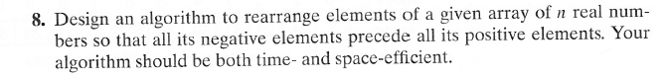
Author's hint for problem 8: Use the partition idea.

