473 Levitin problems and hints HW 06

Problem 1: (6) 3.5.3 [5.2.3]
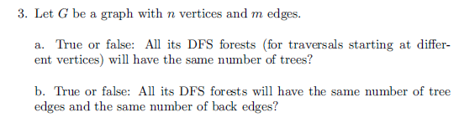
Author's Hints:
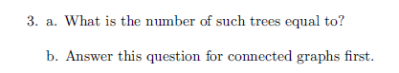

Problem 2: (10) 3.5.8a [5.2.8a]
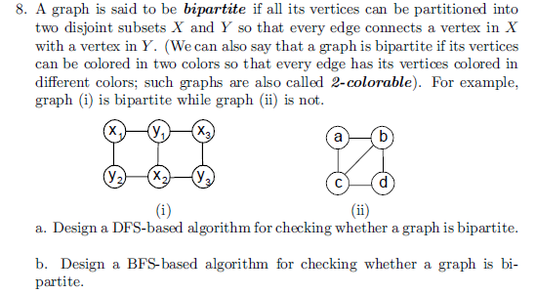
Author's Hints:
Problem 3: (5) 4.1.1 [5.1.1]
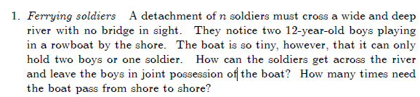
Author's Hints:
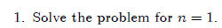
Problem 4: (5) 4.1.4 [5.1.3]
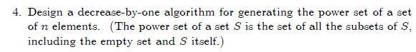
Author's Hints:

Problem 5: (5) (not in book) [5.1.9]
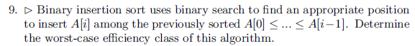
Author's Hints:
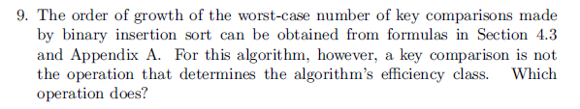
In the 3rd edition, it says "Prove that a nonempty dag must have at least one source." That additional word is necessary!
Problems 6: (9) 4.2.6 [5.3.6]
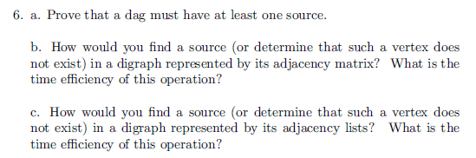
Author's Hints:
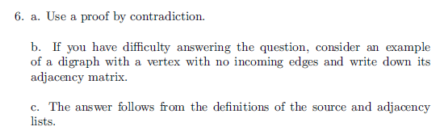

Problem 7: (9) 4.2.9 [5.3.9]
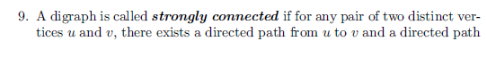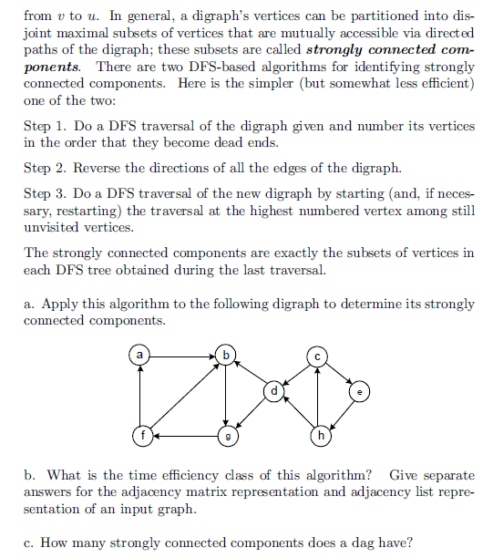
Author's Hints:
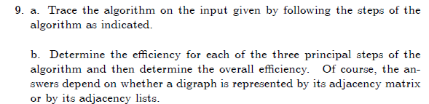

Problem 8: (10) 2.4.14 [ 5.3.10]
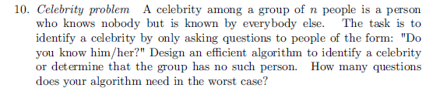
Author's Hints:
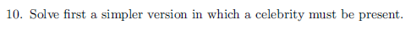
Problem 9: (9) 4.3.2 [ 5.4.2]
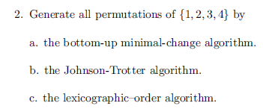
Author's Hints:
Problem 10: (10) 4.3.10 [ 5.4.10]
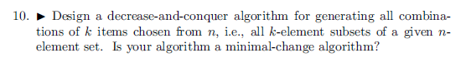

Author's Hints:
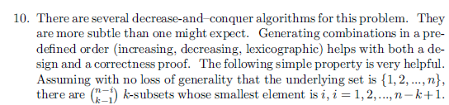

Problem 11: (10) 4.3.11 [ 5.4.11]
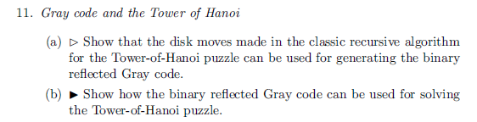
Author's Hints:

