Problem 1: 3.2.3 (also see details in assignment document]
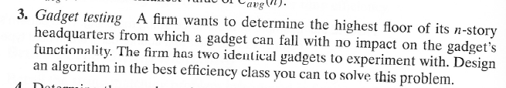
Let N be the total number of floors, and F the number of the lowest floor on which a gadget fails when dropped from there.
Assume that due to weight, volatility, or some other factor, there is a high cost (C) for each floor that a gadget must be carried up. Also a cost (T) for each test to determine whether the drop caused the gadget to fail after each drop.
First, give big-Theta worst-case running times in terms of N, C, and T for the obvious algorithm that tries every floor in succession (that algorithm only requires one gadget). Then design and analyze the most efficient algorithm you can.
Can you think of any flaws in this general approach to testing?
Problem 2: 3.2.4
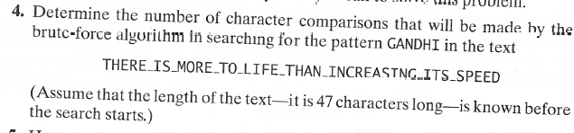
Problem 3: 3.2.6
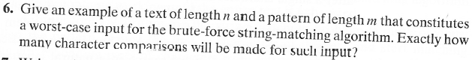
Problem 4: 3.3.4 [3.3.3]
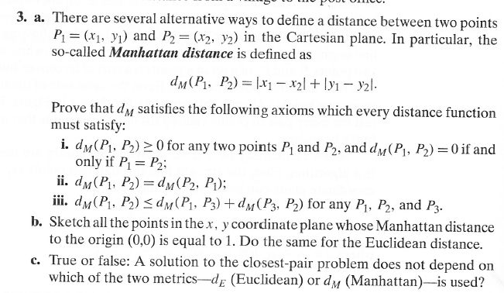
Clarifications: (b) You can sketch or simply list them.
(c) By "a solution", they mean "an algorithm to solve the problem".

Problem 5: 3.3.7 [3.3.5]
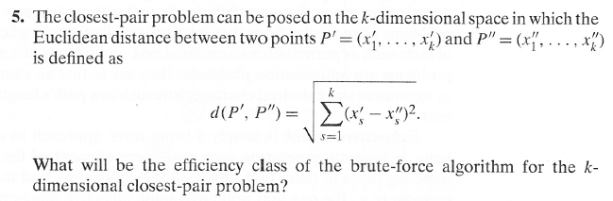
Problem 6: 3.3.10 [ 3.3.8]
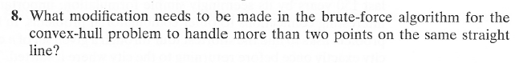
Problem 7: 3.4.1 (traveling salesman)
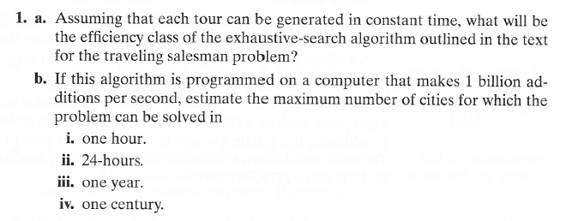
Problem 8: 3.4.5
Problem 9: 3.4.6
