HW 13 textbook problems and hints
8.1 (5 – 5, 10 - 10)
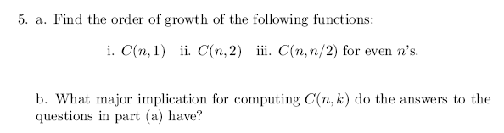
Author's hint:
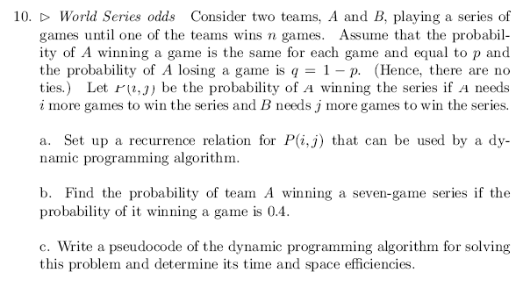
Author's hint:
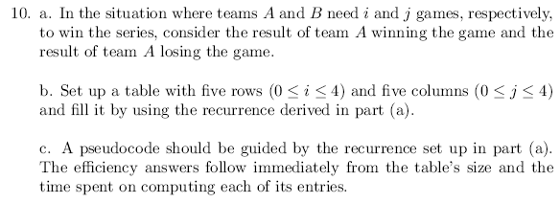

8.2 (3 – 5, 4 - 10)
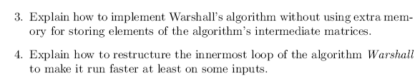
Author's hint:
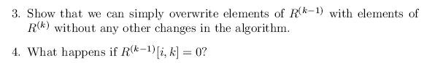
OptimalBST problem #5 (50 poionts, long description is in the assignment document)
8.3 (6 – 10, 7 - 5)
Author's hint:
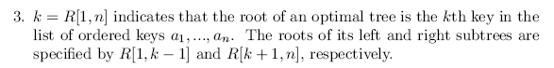
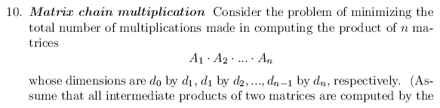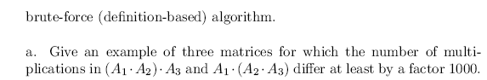
Author's hint:
