HW 12 textbook problems and hints
7.1 (1 - 10)
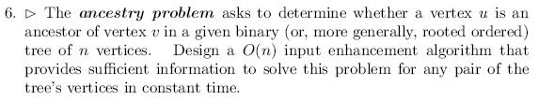
Author's hint:
7.2 (2 – 6, 3 – 9, 4 - 4)
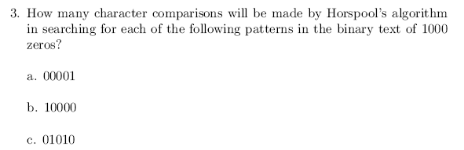
Author's hint:
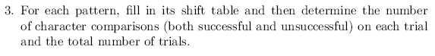
+++++++++++++++++++++
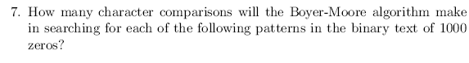
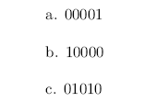
Author's hint:
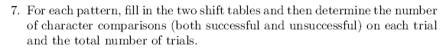

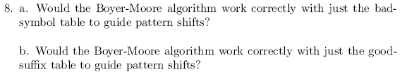
Author's hint:
7.3 (5 - 5)
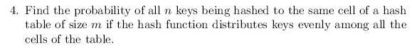
Author's hint:
7.4 (6 - 6)
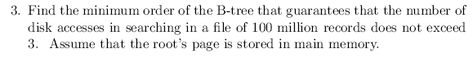
Author's hint:

