HW 11 textbook problems and hints
5.6 (1 - 20)
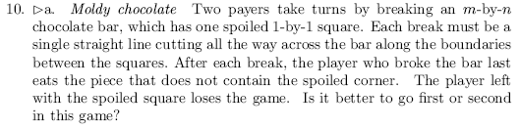
My instructions from the assignment document: This problem may be harder than it looks at first.
Perhaps it is no accident that the problem is in section 5.6, and also very close to Chapter 6.
"Transform and conquer" is a good way to find a complete solution. However,
If you can't solve the general case, solve some cases that you can solve, and talk about what you tried
for other cases.
Author's hint:
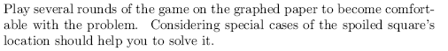
6.1 (2 - 10)
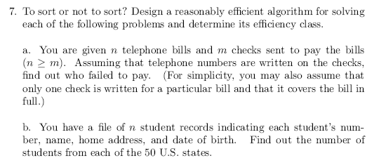
Author's hint:
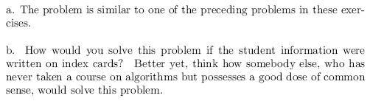

6.2 (3 - 10) problem 8c
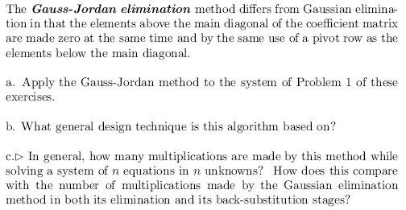
Students are only required to do part c. I put the rest here for context.
Author's hint:
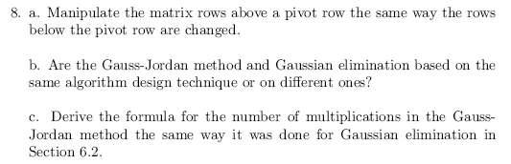
6.3 (4 - 6)
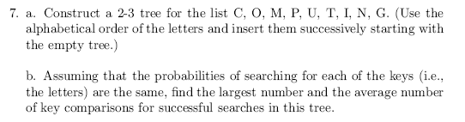
Author's hint:
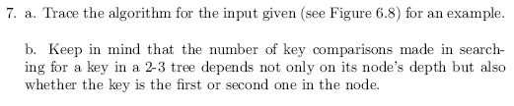
#5 (25, not from textbook)
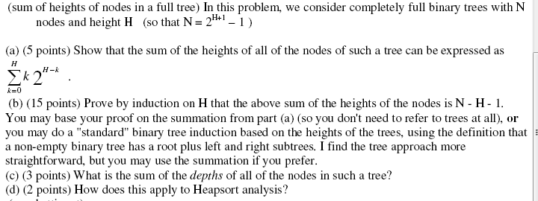
6.4 (6 - 10)
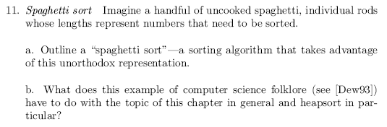
Author's hint:
6.5 (7 - 3)
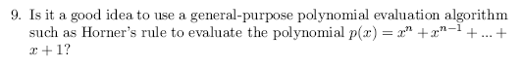
Author's hint:

