HW 10 textbook problems and hints
5.5 (1) (12)
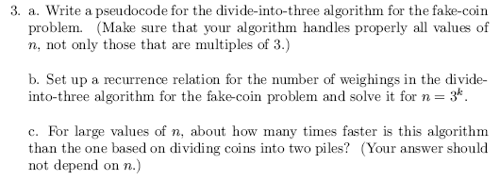
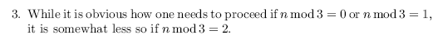

- ( 5) Which permutation immediately follows 37246510 in lexicographic order?
Show how you use the algorithm from Day 21 class to get your answer.
- ( 5) If the permutations of the numbers 0-7 are numbered from 0 to 8!-1,
what is the (lexicographic ordering) sequence number of the permutation 37246510?
- ( 5) Which permutation of 01234567 is number 25000 in lexicographic order?

