HW 01 textbook problems and hints
1.1 (1 – 5)
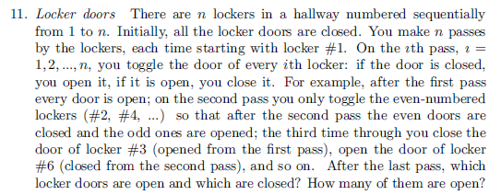
1.2 (2 - 5) (four people and a flashlight)
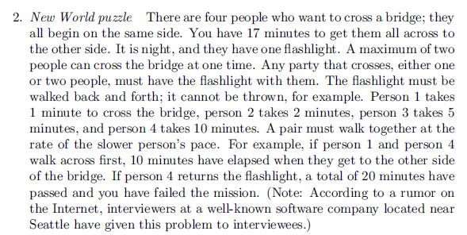
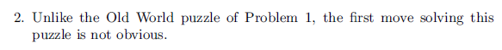

1.3 (3 - 5) (are n given points on circumference of the same circle?). Input: a list of coordinates, output: boolean.
You can be brief, but do not be so vague that I cannot tell whether you really know how to do this.

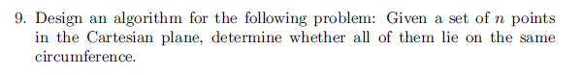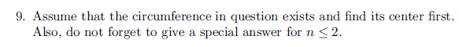

1.4 (4 – 6, 5 – 5, 6 - 3)
