MA/CSSE 473 Day 27 Dynamic programming intro
- In what situation can dynamic program speed up the runtime of an algorithm?
- How does Dynamic Programming improve the performance of Fibonacci computation (compared to just using the recursive formula?
- What is the recursive formula used by the dynamic programming algorithm for binomial coefficients?
- Transitive closure of a directed graph
  - How to compute it using matrix multiplication
  - Number of integer multiplications required for this approach.
  - Warshall’s algorithm
    - Number the vertices: v₁, v₂, …, v_{n}
    - Graph represented by a boolean adjacency matrix M.
    - Numbering is arbitrary, but is fixed throughout the algorithm.
    - Define the boolean matrix R^{(k)}:
    - R^{(k)}[i][j] is 1 iff there is a path from v_{i} to v_{j} in the directed graph
that has the form v_{i} = w₀ → w₁ → … → w_{s} = v_{j}, where
      - s >=1, and
      - for all t = 1, …, s-1, the w_{t} is v_{m} for some m ≤ k
i.e, none of the intermediate vertices are numbered higher than k
    - What is R⁽⁰⁾?
    - Note that the transitive closure T is R^{(n)}
    - 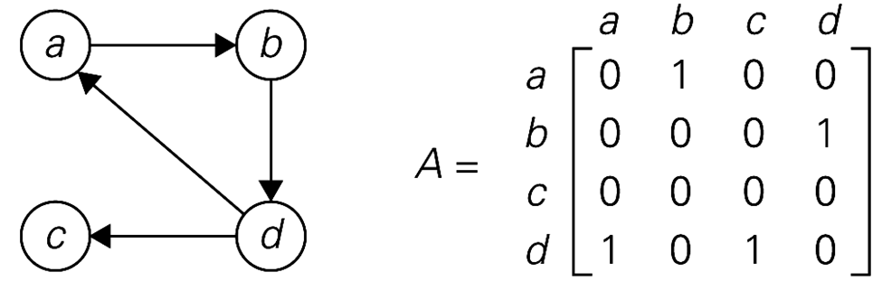
    - A quicker way to calculate R^{(k)} from R^{(k-1)}

- Optimal linked list order (if we know the probability of search for each item)
  - Item x_{i} in list has probability p_{i}. What is expected number of probes for search?
  - Example: p₁ = ½, p₂ = ¼, …, p_{n-1} = 1/2^{n-1}, p_{n} = 1/2^{n-1}
Expected # of probes for best case, worst case:
  - What if we do not know the probabilities?
- Optimal binary search tree (for case where we know the probabilities (or frequencies)
  - For today, we only deal with successful searches.
  - If P(x_{i}) = p_{i}, what is the expected number of probes for a search?
  - Guiding principle for optimization
- How many different BSTs with n nodes (containing numbers 1, 2, …, n)?
- Example: consider only successful searches, with probabilities A(0.2), B(0.3), C(0.1), D(0.4).
worst opposite greedy
better best?

