MA/CSSE 473 Day 24
Background for next three parts: http://www.rose-hulman.edu/class/csse/csse230/201230/Slides/17-Graphs-HashTables.pdf
- (with partners) Quickly discuss these issues.
What problem do we try to solve by hashing?
What is the general idea of how hashing works?
Why does it fit into Chapter 7 (space-time tradeoffs)?
What are the main issues to be addressed when discussing hashing implementation?
How to choose between a hash table and a binary search tree?

- Discuss with partners to be sure that you can define these terms:
hash function, collision, load factor, perfect hash function, open addressing, linear probing, cluster,
quadratic probing, rehashing, separate chaining. When doing an insertion into the table, how does the value of λ affect expected number of probes? If you need hints, see the PowerPoint slides that are linked above
http://www.rose-hulman.edu/class/csse/csse230/201230/Slides/17-Graphs-HashTables.pdf

- (with partners again) Suppose we have a table size of 19, the identity function h(key)=key as the hash function, and use linear probing for collision resolution. The following numbers are inserted in the table in the given order. Beside each number in the left table, write the array index where the value ends up, and the number of times we will have to probe the table before we find the correct place to insert that number (the number of probes will always be at least 1). You can use the second set of tables to help you do this.
For the middle table, do the same thing, but with quadratic probing. H, H+1², H+2², H+3², H+4², …
For the right table, use double hashing (rehashing) adding h2(key) = key % 4 to the array position for each new probe.
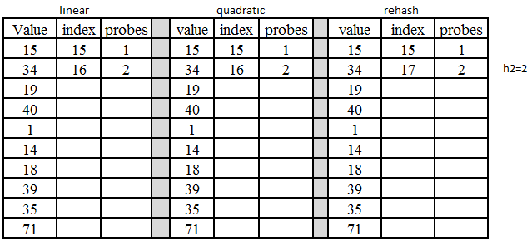
(more on next page)
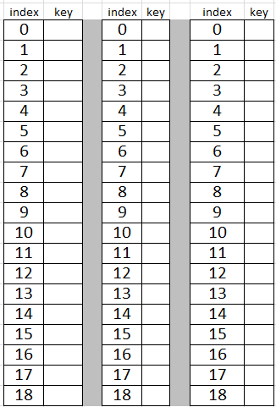
- Show by contradiction that if p is a prime number larger than 3, if i and j are both ≤ ⌊p/2⌋, and if i≠j,
then H + i² ≢ H + j² (mod p).

- In string search algorithms, to what do the terms pattern and text refer?

pattern:
text:

- What is the main source of inefficiency in brute force string searching?

- What is unusual about the comparison order in Horspool's string search algorithm?
- If the text character that we compare to the last pattern character occurs nowhere in the pattern, how far right can we shift the pattern, and still be sure that we do not miss a match?

