MA/CSSE 473 Day 20
- What is the recurrence relation for J(n)?
Base case:
If n is even?
If n is odd?
Use it to calculate J(n) for n = 1…8.
Now use the “cyclic bit shift” approach to calculate the same values.

- According to Levitin, what are the three varieties of transform-and-conquer algorithms?
a)

b)

c)
- How does presorting make finding the mode of elements in an array simpler and faster?
- How can you use presorting to simplify finding anagrams?
- What is meant by an "augmented matrix" used in solving a system of linear equations?
- What are the elementary operations used in Gaussian elimination?
a)
b)
c)

- What is LU decomposition, and how (and when) can it help in the solutions of systems of linear equations?
(these review questions are not to be answered in class. At some point, you should make sure you can answer them).
How can we show that the maximum height of an AVL tree with n nodes is Ѳ(log n)?
What extra data must we store in each AVL tree node in order to efficiently keep the tree balanced?
Give a high-level description of the algorithm for ensuring that an AVL tree is balanced after we do an insertion. You do not need to describe the details of particular rotations.
What is the maximum number of rotations required to rebalance an AVL tree after an insertion? Circle one
Θ(1) Θ(log n) Θ(n) Θ(n log n) Θ(n²)
If a rotation is required after insertion, which of the following applies to the height of the tree after the insertion and rotation? Circle one.
  - Height is always the same as before the insertion.
  - Height is usually the same as before the insertion, but may be larger.
  - Height is usually the same as before the insertion, but may be smaller.
Write a Θ(log N) function which, given a pointer to the root of an AVL tree, returns the height of the tree.
- Review a proof that the maximum height of a height-balanced tree with N nodes is Θ (log N):

- What property do all of the leaves in a 2-3 tree have?
- What are the upper and lower bounds on the height of a 2-3 tree with n elements?
- Continue the following sequence of 2-3 tree insertions by adding 10, 11, 12, …
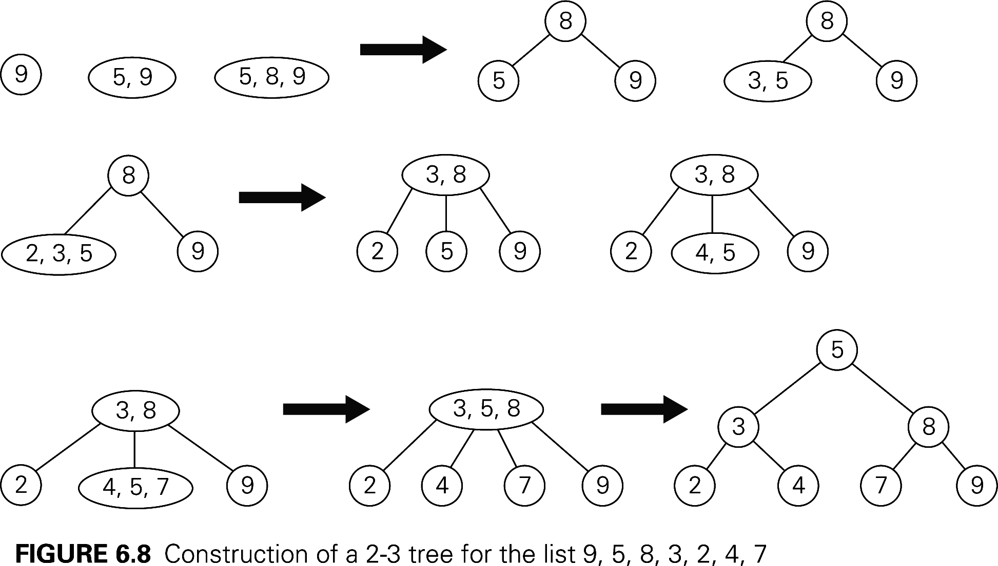

- Show the result of inserting 84 into this tree: 