MA/CSSE 473 Day 13
- Topological sort: In a dag, the vertices can be linearly ordered so that every edge's starting vertex is listed before its ending vertex.
- Two Topological sort algorithms (for a dag):
  - Based on DFS.
    - Do a DFS, keeping track of the order in which the nodes are popped off the stack.
    - Reverse the order.
  - Source removal algorithm.
Repeatedly identify and remove a source node. If there are no cycles, there will always be a source.

Permutation generation: We want to generate all permutations of the numbers 1, 2, …, n.
- Bottom-up algorithm. Alternate the insertion orders.

- Johnson-Trotter. Every element has an additional piece of info, its direction (right or left).
  - An element is mobile if the element it “points to” is smaller than itself.
  - Largest mobile element is swapped with the element it points to.
  - Then reverse the direction of all larger elements.
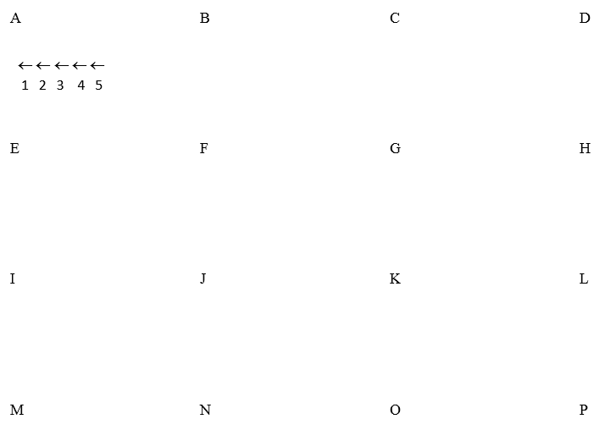

- Which permutation follows each of these in lexicographic order?

183647520 471638520
- Write an algorithm for generating the next permutation, with only N and the current permutation as input.

- If the lexicographic permutations of the numbers [0, 1, 2, 3, 4] are numbered starting with 0, what is the number of the permutation 14023? How do you get this?

- Write an algorithm which, given a permutation of the numbers 0..N-1, calculates its (zero-based) position in the lexicographic ordering of all of the permutations of 0..N-1.
- In the lexicographic ordering of permutations of [0, 1, 2, 3, 4, 5], which permutation is number 568? How do you get this?

