MA/CSSE 473 Day 12
- A Decrease-by-one algorithm: Interpolation sort.
  - What is the basic idea when choosing where in the array to probe?
  - What assumption is made concerning the data?
  - Worst case running time? How can this happen?
  - Average running time?
- Some “decrease by one” algorithms:
  - Insertion sort, Selection Sort
  - Depth-first search of a graph, breadth-first search of a graph
  - Subset generation, permutation generation
- Breadth-first search and depth-first search are graph traversal algorithms.
  - Depth-first search (DFS) uses a stack to keep track of unvisited nodes; breadth-first (BFS) uses a queue.
  - Analogous to pre-order and level-order traversals of a tree.
  - DFS goes deep, quickly. BFS searches nearby nodes first.
  - In a connected, undirected graph, both generate a tree and “back edges”`.
- For the following undirected graph, do a DFS search (starting at a, and always preferring nodes whose names come earlier alphabetically). Show the stack, and the order of pushes and pops.
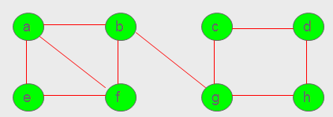

- For the same undirected graph, do a BFS search (starting at a, and always preferring nodes whose names come earlier alphabetically). Show the queue, and the order of enqueues and dequeues.

- In an undirected graph, each edge goes in only one direction. A dag is a directed acyclic graph, i.e. a directed graph with no (directed) cycles.
- Topological sort: In a dag, the vertices can be linearly ordered so that every edge's starting vertex is listed before its ending vertex.
- Two Topological sort algorithms (for a dag):
  - Based on DFS.
    - Do a DFS, keeping track of the order in which the nodes are popped off the stack.
    - Reverse the order.
  - Source removal algorithm.
    - Repeatedly identify and remove a source node. If there are no cycles, there will always be a source.
- Application of topological sort: Spreadsheet formula evaluation.
- (Probably next time) Generate all permutations of the numbers 1, 2, …, n. Bottom up. Minimal change algorithm.

