MA/CSSE 473 Day 11
- Donald Knuth is a VIP in the world of algorithms. Let’s talk about him.

- What does amortize mean?
- Suppose we are implementing ArrayList, starting with a capacity of 5 elements, and increasing the size as needed. If we start with an empty ArrayList and add elements one at a time until we get N elements, (we don't know N in advance), what is the amortized cost of adding each element if we use the following strategies for resizing the array?
– add one element to the capacity each time

– double the capacity each time (you may assume that N is one more than 12 times a power of 2)

- What is a brute force algorithm?
- According to the Levitin textbook, what are the three flavors of decrease-and-conquer algorithms?
a
b
c
- Some “decrease by one” algorithms:
  - Insertion sort, Selection Sort
  - Depth-first search of a graph, breadth-first search of a graph
  - Subset generation, permutation generation
- Breadth-first search and depth-first search are graph traversal algorithms.
  - Depth-first search (DFS) uses a stack to keep track of unvisited nodes; breadth-first (BFS) uses a queue.
  - Analogous to pre-order and level-order traversals of a tree.
  - DFS goes deep, quickly. BFS searches nearby nodes first.
  - In a connected, undirected graph, both generate a tree and “back edges”`.
- For the following undirected graph, do a DFS search (starting at a, and always preferring nodes whose names come earlier alphabetically). Show the stack, and the order of pushes and pops.
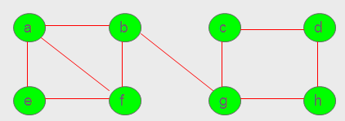

- For the same undirected graph, do a BFS search (starting at a, and always preferring nodes whose names come earlier alphabetically). Show the queue, and the order of enqueues and dequeues.

