MA/CSSE 473 Day 02 Summary
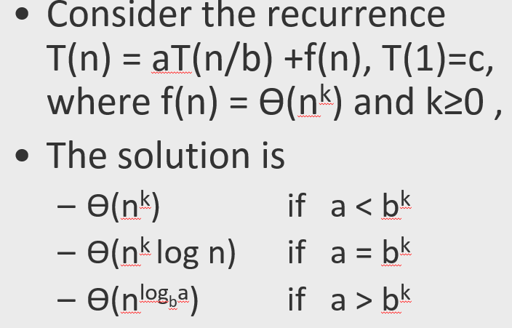
Main ideas from today:
- Master Theorem review:
- What are the a, b, and k for binary search?
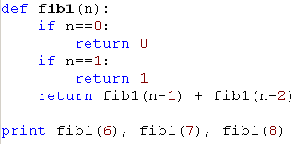
- What are the a, b, and k for merge sort?
- Analysis of recursive Fibonacci algorithm:
Recurrence for number of operations:
Show by induction that T(N) > F(n):

How long to compute F(200) on an exaflop machine (10^18 operations per second)?
Linear algorithm?
Better than linear, using matrices?

- When we add three 1-digit integers, how many digits can be in the answer? Is this independent of the base (i.e, the same for decimal, binary, hexadecimal, etc.).

- How does the previous question apply to the analysis of the addition of two k-bit non-negative integers?
- What about multiplication of two k-bit integers?

