Statement of the lemma from the slides:
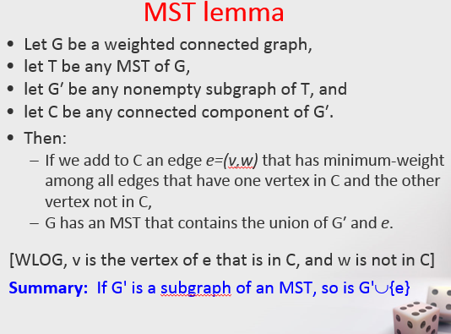
Notation , hypothesis, and conclusion of the lemma:
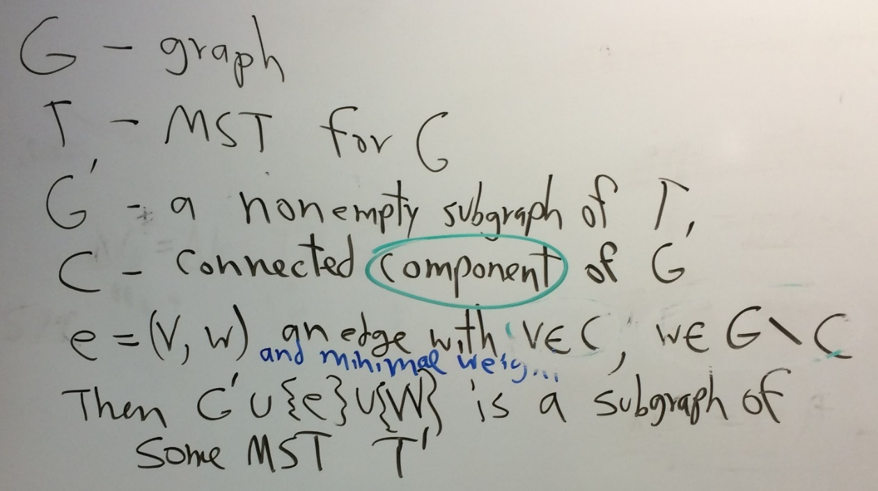
w was left out of the lemma’s conclusion on the slides. w may already be in G’; if not, we need to add it when we add a new edge.

Big picture: We have a subgraph (call it G’) of a MST T for G. We want to add another edge in such a way that the union of G’ and this edge is a subgraph of a MST T’ of G. T’ may or may not be the same MST as T. But what matters is that if we follow this rule for choosing e, we will always get a subgraph of a MST. IN both Kruskal’s and Prim’s algorithms, the rule for choosing the next edge satisfies the hypothesis of this lemma, so after each edge choice, we will have a subgraph of a MST
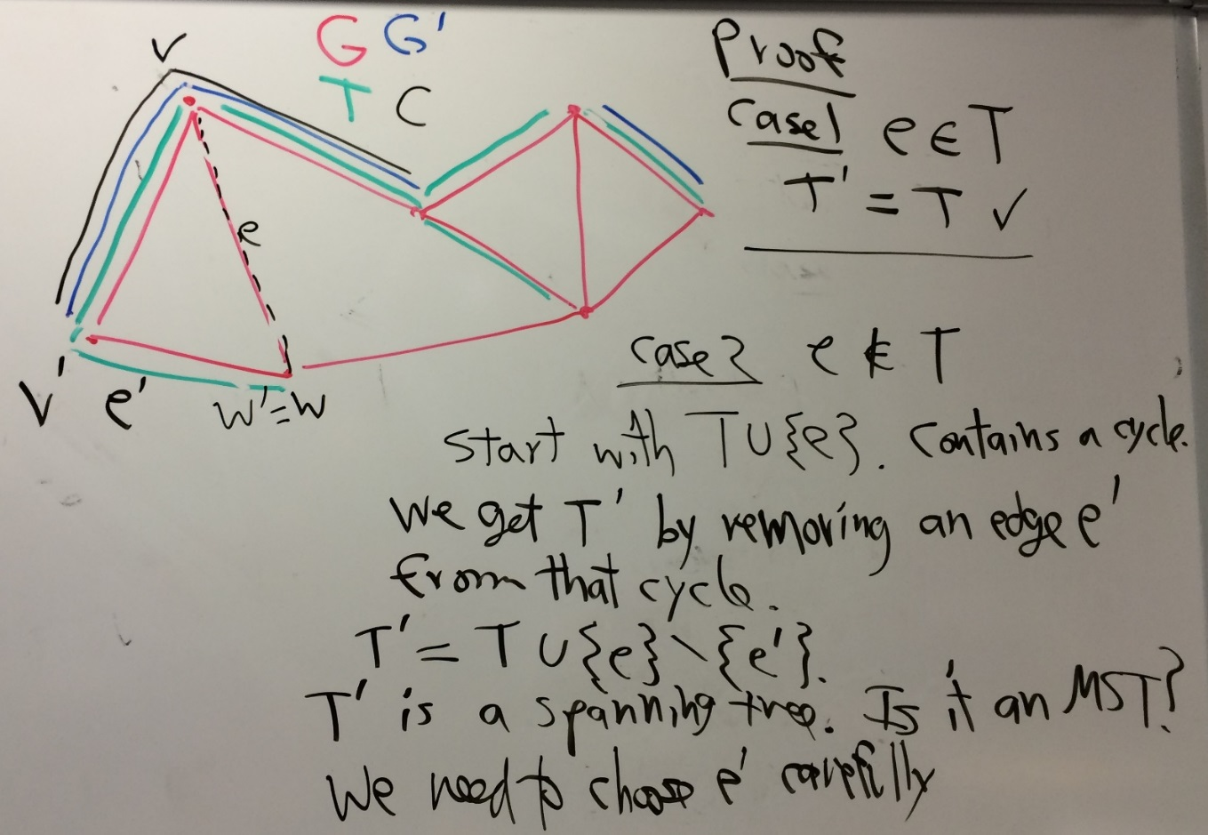
So we show how to choose e’ so that T’ is a MST, then prove that it actually is a MST
About the diagram:
- Note that parallel lines with different colors in the diagram do not imply multiple edges. They imply that a particular edge is part of multiple named subgraphs.
- To keep the graph less complicated, I did not label the edges with their weights.
G’ is the “subgraph of T” before choosing the next edge, and C is a connected component of G’ (we could have let C be the other connected component of G’ in the diagram)
- E is the “added edge”, chosen according to the criterion of the lemma’s hypothesis; there are three other edges that would have been candidates for e; I assume that the pictured e was a minimal-weight edge among those 4.
How to choose e’ so that T’ is a minimal spanning tree, then show that it actually is a MST:
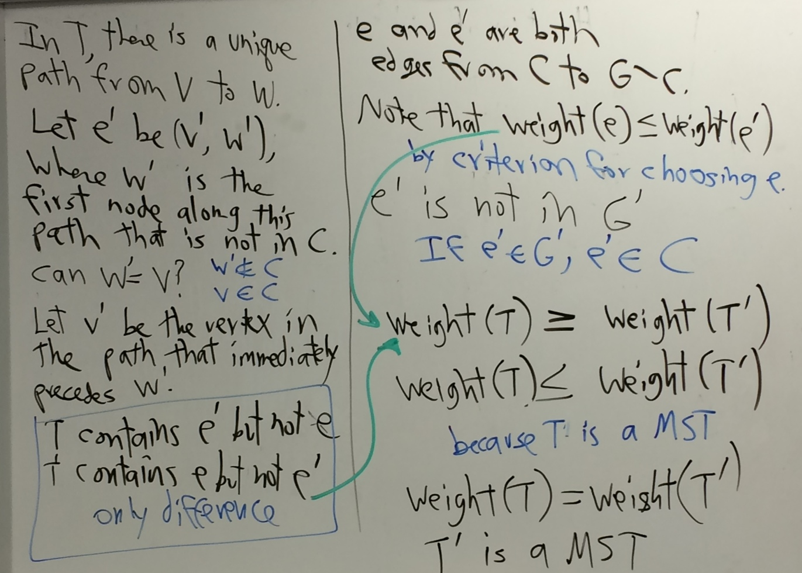

In the particular graph that I drew, w’ is the same as w. IN a more complicated graph, this may not be the case.
The above image completes the proof of the lemma.

Now we use the lemma to show that Kruskal’s algorithm actually produces a MST for G.
First we prove by induction:
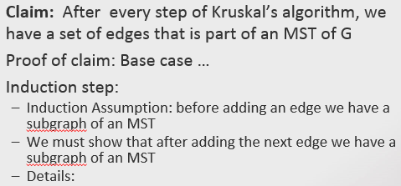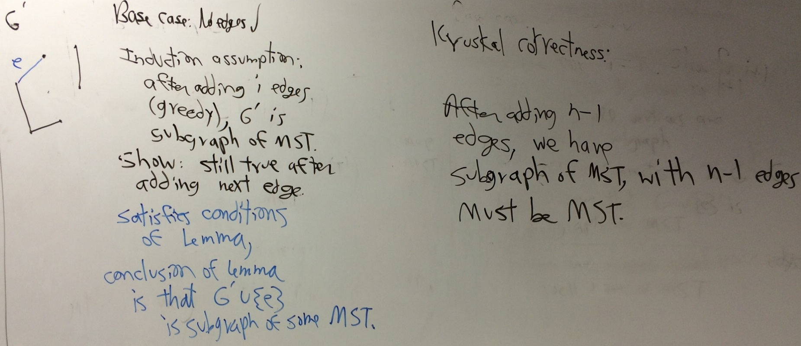

Some things I might ask on the final exam:
First, you do not need to memorize the proof. I could give you part or all of the proof and ask you to
- Explain why some of the steps are valid.
- Give you a different diagram with a specific G, T, G’, C, and E, and ask you to label other parts, such as v, w, v’, w’, e’, T’.

