473 Levitin problems and hints HW 09B

Problem 1: (2 points) 4.4.13 [5.5.7] Find J(40)–the solution to the Josephus problem for n = 40
Author's Hints: The fastest way to the answer the question is to use the formula that exploits the binary representation of n, which is mentioned at the end of the section.

Problem 2: (20 points) 4.4.15ab [5.5.9ab] For the Josephus problem,
- (5) compute J(n) for n = 1, 2, …, 15. (Instructor note: We started this table in class)
- (15) discern a pattern in the solutions for the first fifteen values of n and prove its general validity by induction, based on the Josephus recurrence relations from the textbook.

Author’s hints:

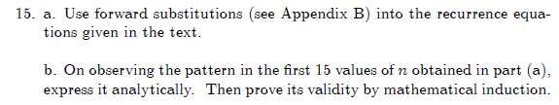
4.5.11a: This problem may be harder than first appears to be. You should provide an analysis in terms of m, n, and the (i, j) position of the moldy square For some values of (m, n, i, j), the first player can always win; for others the second player can always win. What is the winning strategy?
However, if you can't solve the general case, you may get some partial credit by solving the cases that you can solve, and writing about what you tried for other cases.
"Transform and conquer" is a good way to find a complete solution, so you may want to look ahead to Chapter 6 to give you some ideas of how “T & C” works.
In the past, several students said that this problem took them longer than any previous problem in the course.

Problem 3: (20 points) 4.5.11a[5.6.10a]
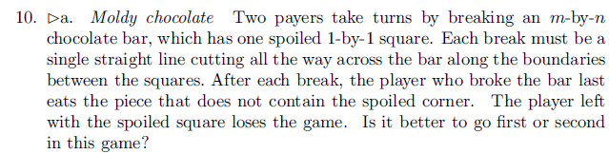
Author's Hints: 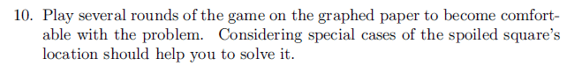

Problem 4 (10 points) 6.1.5 [6.1.7]
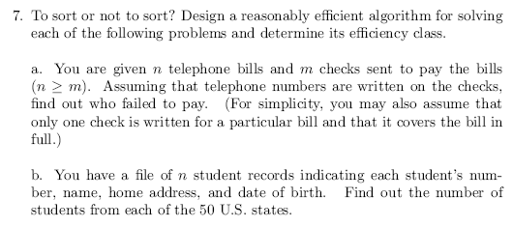
Author's hint:
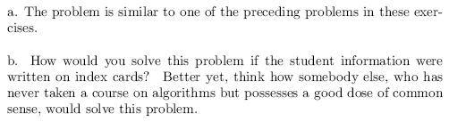

Problem 5: (10 points) 6.28c
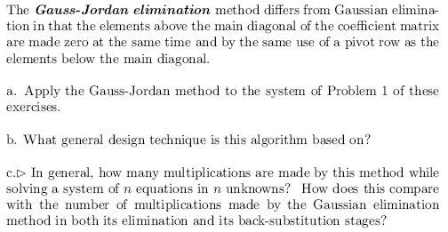
Students are only required to do part c. I put the rest here for context. You should compute and compare actual number of multiplications, not just say that both are Θ(n^3). Use division when you compare.
Author's hint:
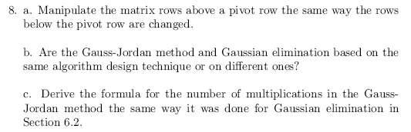
Problem 6 (6 points) 6.3.7
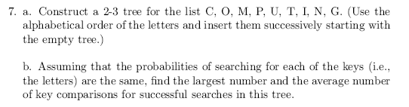
Author's hint: (see instructor notes on next page)
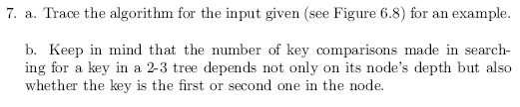
Instructor notes
You must (a) show the steps in constructing the tree, and (b) show the details of the average-case calculation.
Problem 7 (3 points) 6.3.8
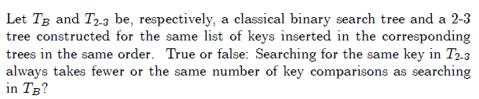
Author's hint:
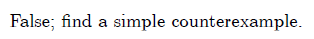
Problem 8 (3 points) 6.3.9
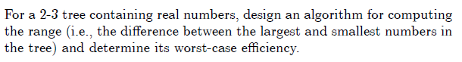
Author's hint:

