473 Levitin problems and hints HW 07

Problem 1 5.2.8 [4.2.8] (Negatives before Positives)
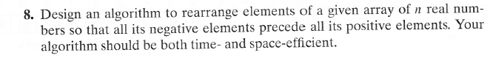
Author's hint for problem 1: Use the partition idea.
Problem 2: (8) 5.2.9 [4.2.9] (Dutch National Flag)
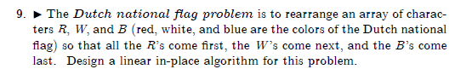
Author's Hints:
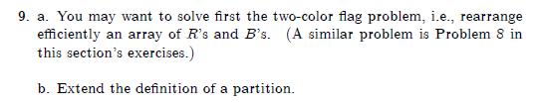
Note: THIs is two different hints for one problem, not hints for two parts of the problem (there is only one part).

Problem 3: (5) 4.1.4 [5.1.3] generate power set
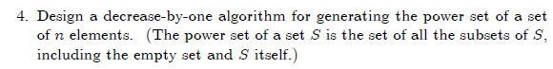
Author's Hints:
Problem 4: (9) 4.3.2 [ 5.4.2] Examples of permutation generation algorithms
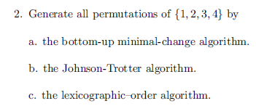
You do not have to write any code, but you can do it that way if you wish.
Author's Hints:
Problem 5: (10) 4.3.10 [ 5.4.10] Generation of all k-combinations from an n-element set
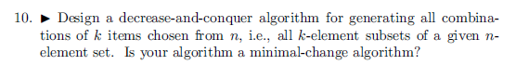
Author's Hints:
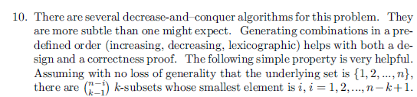

Problem 6: (10) 4.3.11 [ 5.4.11]
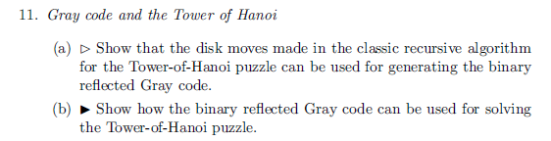
Author's Hints:
Problem 7: (10) 4.3.12 Not in 2nd edition
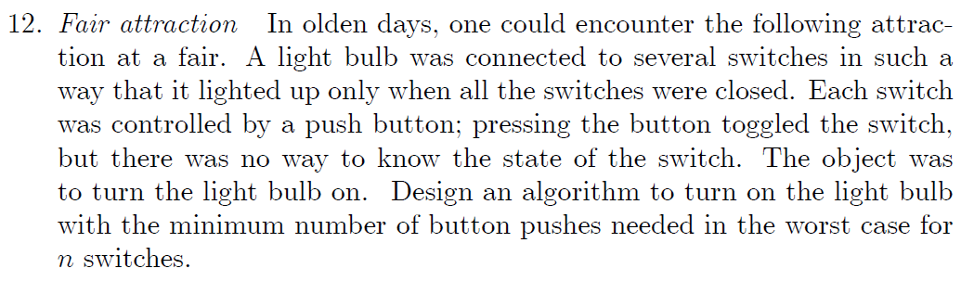
Author's Hints:
