473 Levitin problems and hints HW 06B

Problem 1: (6) 3.5.3 [5.2.3] Independence of properties from specific DFS traversals. Explain your answers.
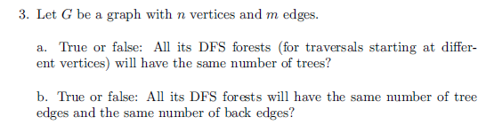
Author's Hints:
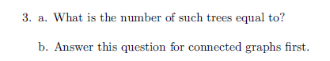

Problem 2: (10) 3.5.8a [5.2.8a] Bipartite graph checking using DFS
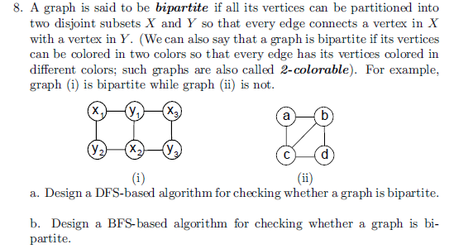
Author's Hints:
Problem 3: (5) 4.1.1 [5.1.1] Ferrying Soldiers
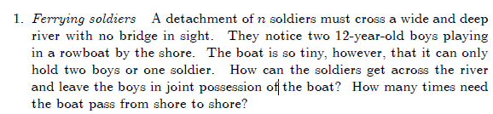
Author's Hints:
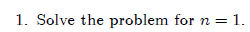

Problem 4: (5) (not in 3rd edition) [5.1.9] binary insertion sort efficiency
Binary insertion sort uses binary search to find the appropriate position to insert A[i] among the previously sorted A[0] ≤ … ≤ A[I - 1]. Determine the worst-case efficiency class of this algorithm. I.e. get big-Θ time for number of comparisons and number of moves.

Author's Hints:
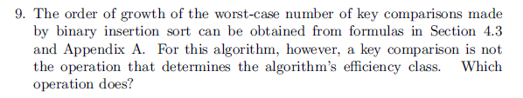
In the 3rd edition, it says "Prove that a nonempty dag must have at least one source." That additional word is necessary!
Problems 5: (9) 4.2.6 [5.3.6] dag source


Author's Hints:
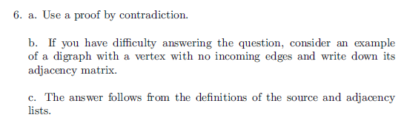

Problem 6: (9) 4.2.9 [5.3.9] Strongly connected components of a digraph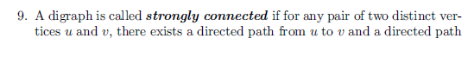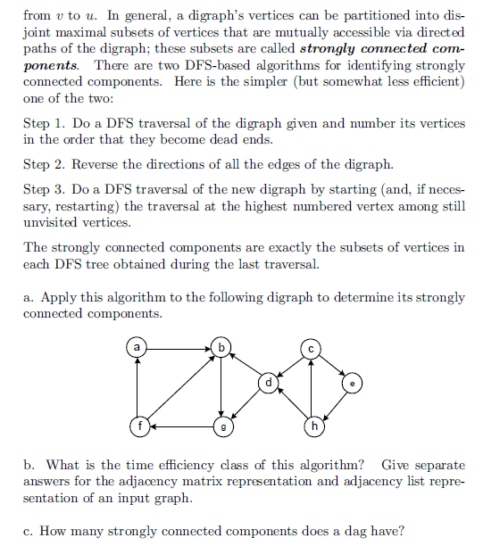
Author's Hints:
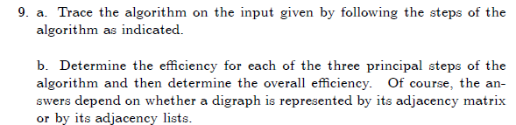

Problem 7: (20) Not from the textbook.
