CSSE 473 HW #3 Levitin problems (3rd edition) from Section 3.1
The other problems that are not from the textbook are not listed in this document.
All of their details are in the HW3 assignment document.
For these problems, assume that arithmetic operations are constant time.
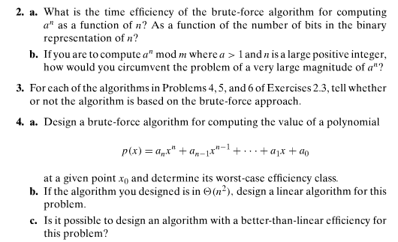
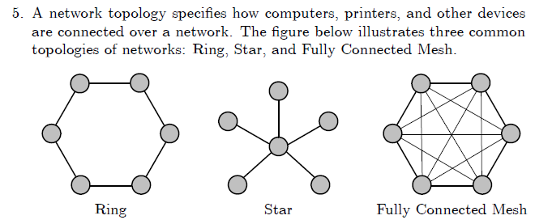
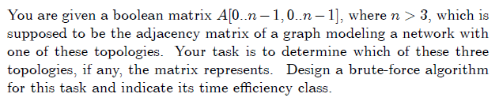

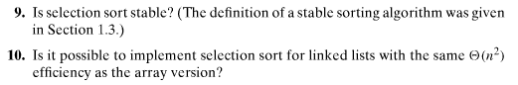
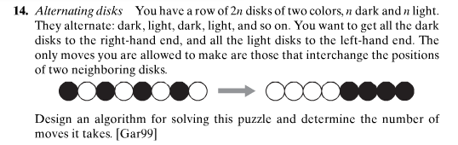

Author's hints on next page:

Author's hints: Section 3.1
