HW 02 textbook problems and hints
Section 2.1 (Problem 1 – 6 points, 2 - 6)
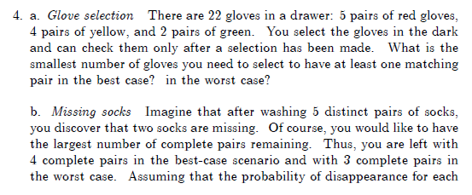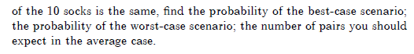
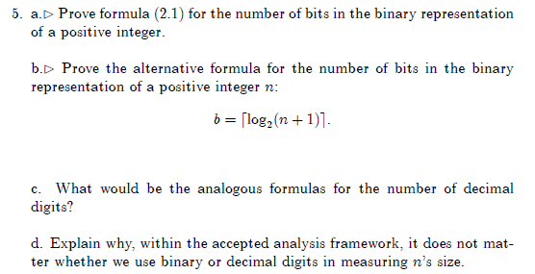
HINTS from the textbook (problems 1 and 2):
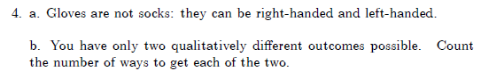
Instructor clarification: A “selection”does not mean choosing a single glove. It means choosing all of the gloves or socks that you are going to choose. You don’t look at any of them until you havre chosen all of them.

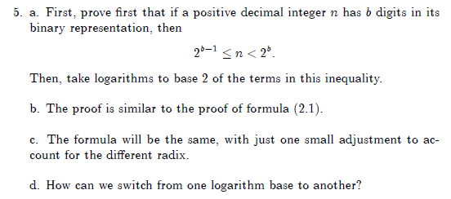
Instructor note: Note that there are four parts of this problem
2.2 (3 – 10, 7 – 4 (parts a and d only), 12 -- 6)
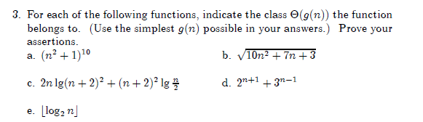
Instructor note for 2.2.3: For parts a&b, use limits;
for e, use formal definitions of O and Ω; you should find specific values for the c and n₀ in the formulas on
pages 53-55.
for c & d, you can use the theorem on p 56.
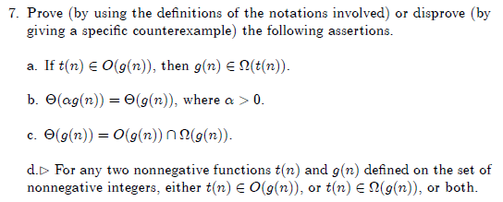
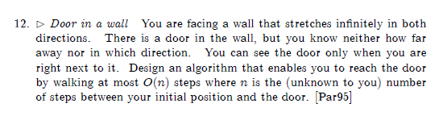
HINTS from the textbook (problems 3, 4, and 5):
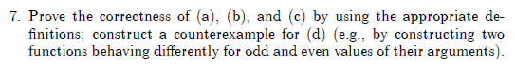
Instructor note on 2.2.12[2.2.10]: Show that your algorithm is actually O(N).
2.3 (6 – 8, 7 - 10)
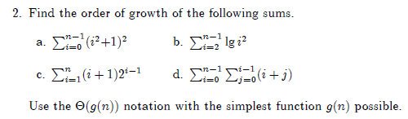
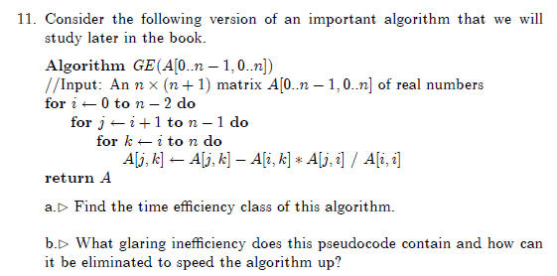
Instructor note Include a quantitative indication of how much time is gained by removing the glaring
inefficiency.
HINTS from the textbook (problems 6 and 7):
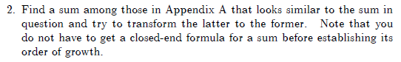
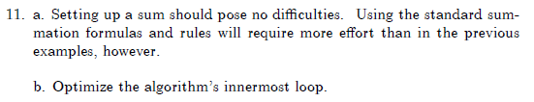

Problem 8: (10) 2.4.14 [ 5.3.10] Celebrity identification

HINTS from the textbook (problem 8):
Instructor clarification:
be sure to start this one early! "Efficient" in this case means making the number of questions for N people as small as you can, and you should say how many questions are required by your approach in the worst case.

- Master Theorem Proof (8 points).
These questions refer to the proof in Weiss section 7.5.3 ( available on ANGEL).
(a) (5 points) (7.11) Why is it O(A^{M})? Why is the second equation true (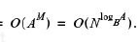)?
(b) (3 points) Sentence after (7.11). Why does the sum contain that many terms? Why does A = B^{k} imply A^{M} = N^{k}?

- Dasgupta questions (6 points, 2 for each part)
(a) What does Dasgupta say are the two main ideas that changed the world? Do you agree? What else might you include in the list?
(b)Why is the simple algorithm at the bottom of page 4 actually not O(n)?
(c) Show how to use al-Khwarizmi's technique to multiply 9 (first column) by 15 (second column).

Note on problem 10. These are easy “did you read this?” problems. On later assignments there will be harder problems based on the Dasgupta excerpt.

- 3.1.7 (5 points) Stack of fake coins. There are n stacks, each containing n identical-looking coins. All of the coins in one of these stacks are counterfeit, weighing 11 grams each, while all the coins in the other stacks are genuine, weighing 10 grams each. You have an analytical scale that can determine the exact weight of any number of coins.
  - What is the minimum number of weighings needed to identify which stack contains the fake coins? Explain.
Author’s hint: The answer is that one weighing is enough. How is this possible?

