MA/CSSE 473 HW 14 textbook problems and hints
Problem #1 (5) 9.4.4 (maximal Huffman codeword length)
Once you have figured out the answer, describe a set of
probabilities (or frequencies) that make that maximum happen.
Author's hint:
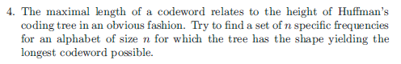
Problem #2 ( 10) 9.4.10 (card guessing)
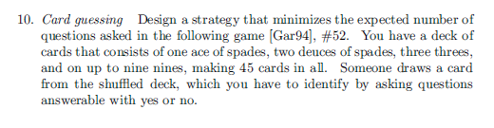
Author's hint:
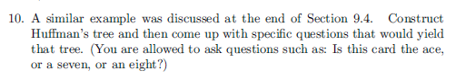
Problem #3 ( 10) Kruskal proof
Problem on Kruskal's algorithm:

The questions
- How do we know that v was already part of some connected component of G'?

Does the addition of e to C satisfy the hypothesis of the lemma? For each statement below, explain why it is true.

- G’ is a subgraph of some MST for G:
(c) C is a connected component of G':
(d) e connects a vertex in C to an vertex in G – C:
(e) e satisfies the minimum-weight condition of the lemma:

The algorithm:
- To find a MST for a connected undirectedG:
  - Start with a graph G' containing all of the n vertices of G and no edges.
  - for i = 1 to n – 1:
    - Among all of G’s edges that can be added without creating a cycle, add one (call it e) that has minimal weight.
The property we are trying to prove: Before every loop execution, G' is a subgraph of some MST of G.

Proof is (of course) by induction on i.
BASE CASE: When I = 1, G' consists of only vertices of G. Since all vertices must be part of any MST for G, G is a subgraph of every MST.
INDUCTION STEP. Assume that G' is a subgraph of an MST for G. Choose e according to the above algorithm. Show that G' ∪{e} is a sungraph of an MST of G.

The Lemma we want to use: Let G be a weighted connected graph with a MST T; let G′ be any subgraph of T, and let C be any connected component of G′. If we add to C an edge e=(v,w) that has minimum-weight among all of the edges that have one vertex in C and the other vertex not in C, then G has an MST that contains the union of G′ and e.
In order to be able to use the lemma, we have to pick a connected component of C, and show that it satisfies the conditions of the lemma. We let v be one of the vertices of e, and let C be the connected component of G' that contains v.

Within this context, answer the 5 questions above.
Problem #4 ( 20) 8.3.11bc [8.3.10bc] matrix chain mltiplication
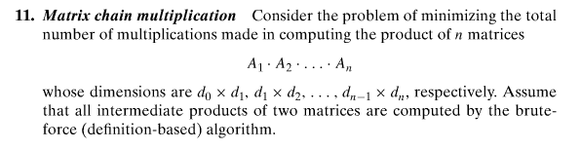
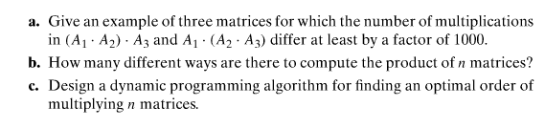
Author's hint:
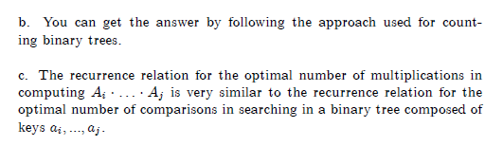
Problem #5 (5) 9.2.8 (efficiency of find in union-by-size)
Author's hint:

Problem #6 (5) 11.1.1 (lower bound for alternating disk algorithm) 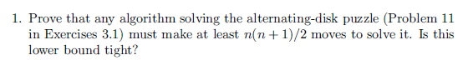 .
Author's hint:
Problem #7 ( 5) 11.1.4 (fake coin minimum number of guesses)
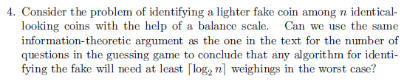
Author's hint:
Problem #8 (12) 11.1.10 (matrix multiplication and squaring) (6, 6)
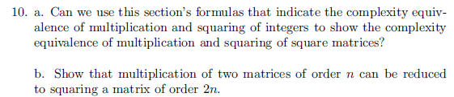
Author's hint:
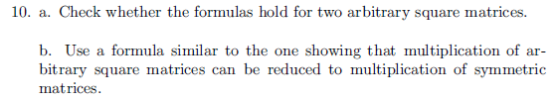

Problem #9 ( 9) 11.2.10ab [11.2.8ab] (advanced fake-coin problem) (4, 5) 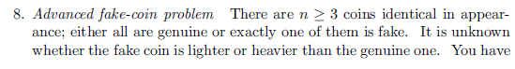
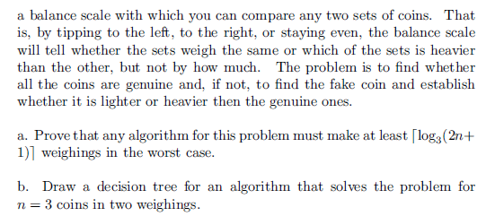
Author's hint
: 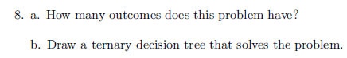
Problem #10 ( 5) 11.3.1 (Chess decidable?) Explain your answer.
. 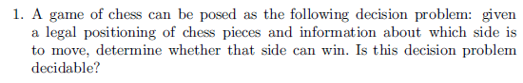
Author's hint:
Problem #11 ( 8) 11.3.2 (tractable?) Explain your answer.
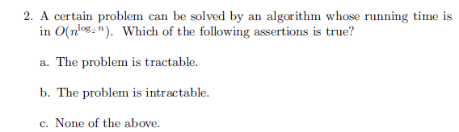
Author's hint:

