MA/CSSE 473 HW 13 textbook problems and hints
Author’s Hints are at the end of this document
Problem #1 (10) 9.1.3 (Greedy job scheduling)
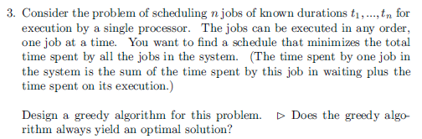
Problem #2 ( 6) 9.1.9b [9.1.7]b (Prim example)
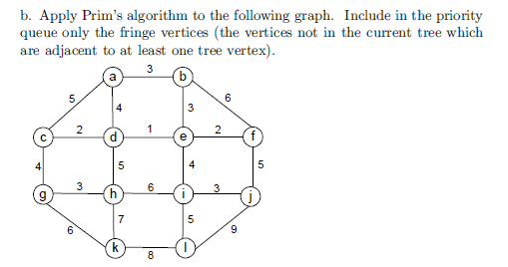

Problem #3 ( 5) 9.1.10 [9.1.8] (Prim prior connectivity check?)
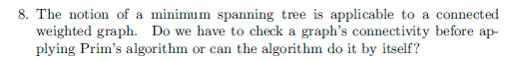
Problem #4 (10) ) 9.1.15 [9.1.11] (change value of an item in a min-heap)
Problem #5 ( 6) 9.2.1b (Krushkal example)
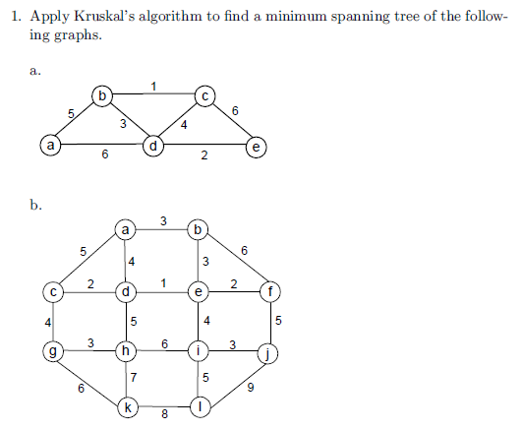
Problem #6 ( 8) 9.2.2 (Kruskal TF questions) Briefly explain your answers.
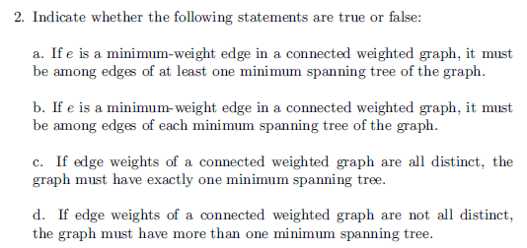

Problem #7 ( 8) 9.4.1 Huffman Code construction
(a) 4 points. When there is a choice due to a tie, place the one that appears first in the problem
statement’s character list “on the left” in the tree. (b) 2 points. (c) 2 points.
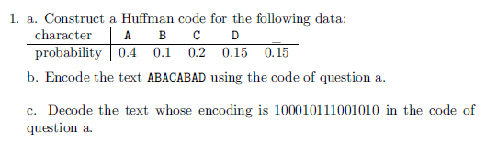
Problem #8 ( 12) 9.4.3 Huffman TF Explain your answers
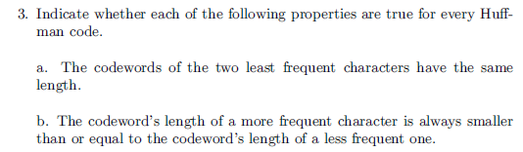
This problem was postponed from HW12 in Winter, 2017.
Problem #9 (5) 8.3.10a ( (Matrix chain multiplication)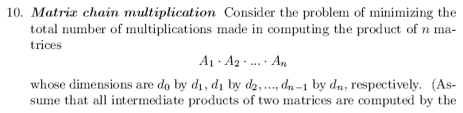
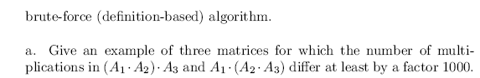

Problem 1 Author's hint:
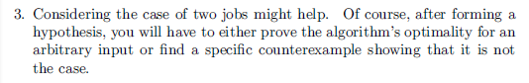

Problem 2 Author's hint:
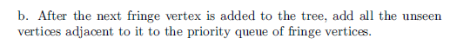
Problem 3 Author's hint:
Problem 4 Author's hint
: 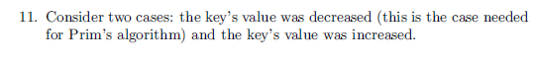

Problem 5 Author's hint:
Problem 6 Author's hint:
Problem 7 Author's hint:
Problem 8 Author's hint:
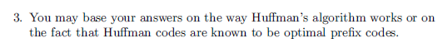
Problem 9 Author's hint:
