HW 12 textbook problems and hints
Note on author’s hints: A student suggested that I put all of the author’s hints at the end, so that students have a chance to think about the problems before they see the hints. I have done that for this assignment.
The original problems 1-2 were removed, and the later problems were renumbered on January 31, 2017
Problem 1: 8.1.12 (10) (World Series odds) Show your work.
Note from Claude: In a 7-game series (such as the real American baseball World Series), the first team to win 4 games wins the series. 7 is the maximum number of games that can be played before one of the teams must win four games. But if one team wins 4 games sooner, the series ends immediately.
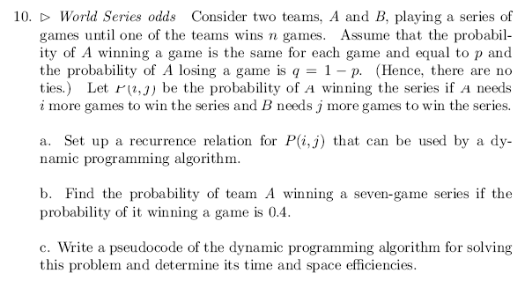

Problem 2. 8.4.3 [8.2.3] (5) (Warshall with no extra memory use)
Problem 3. 8.4.4[8.2.4] (10) (More efficient Warshall inner loop)
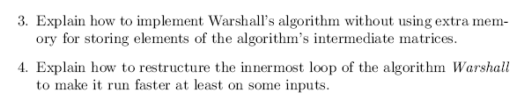
Problem 4. OptimalBST problem (25 points plus extra credit)
Not from the textbook. Description is in the assignment document
Problem 5. 8.3.3 (10) (Optimal BST from root table)
You may do this for the “successful searches only” approach form the Levitin textbook if you prefer.
Problem 6. 8.3.4 (5) (Sum for optimalBST in constant time)
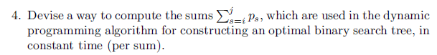
Problem 7. 8.3.6 (10) (optimalBST--successful search only--if all probabilities equal)
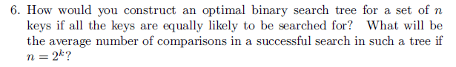
This problem is postponed to a later assignment.
Problem 8. 8.3.10a (5) (Matrix chain multiplication)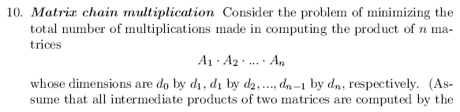
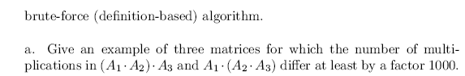

Author's hint, problem 1:
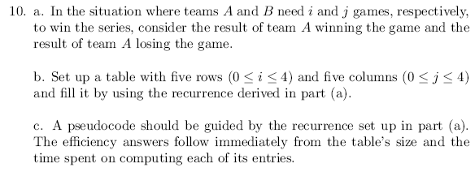
Author's hints, problems 2 and 3:
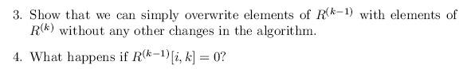
Author's hint, problem 4:
This problem is not from the Leviton textbook; no author’s hints. The details are on the assignment document.
Author's hint, problem 5:
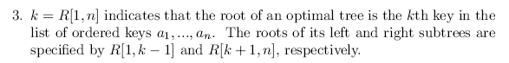
Author's hint, problem 6:
: 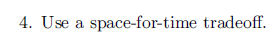
Author's hint, problem 7:
