HW 11 textbook problems and hints
Problem 1 6.5.11 [6.5.10] (6) (Factored form or not) 2 points for each part. Explain your answers.
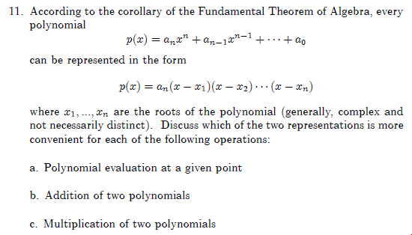
Compare the number of operations needed to implement the task in question.

Author's hint:
Problem 2 6.6.4a (5) (better than cubic check for length 3 cycle in graph)
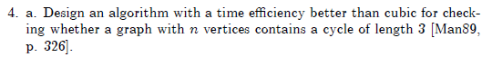
Author's hint:
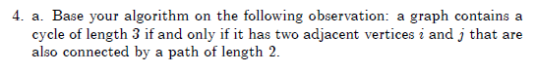

Problem 3 7.2.3 (6) (Horspool for binary strings)
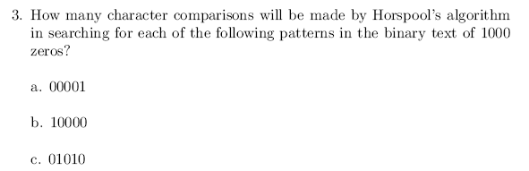
Author's hint:
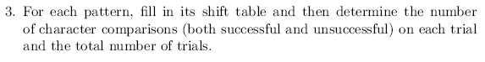
Problem 4 7.2.7 (9) (Boyer-Moore for binary strings)
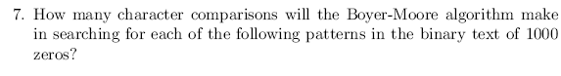
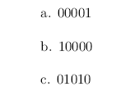
Author's hint:
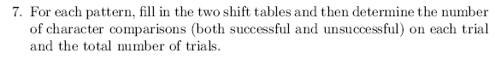

Problem 5: 7.2.8 (4) (does Boyer-Moore still work with just one table?)
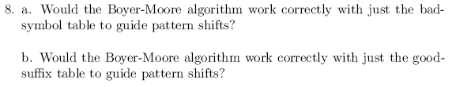
Author's hint:
Problem 6: 7.2.11 (3, 5) (right cyclic shift)
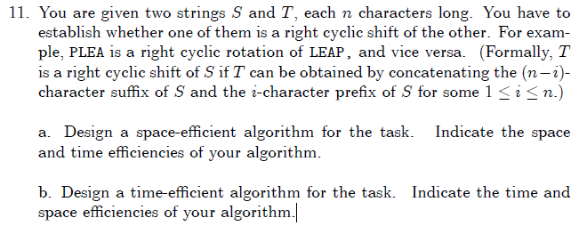
Author's hint:
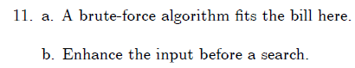

Problem 7: 7.3.4 (5) (probability that n keys all hash to the same table location)
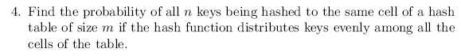
Author's hint:

