MA/CSSE 473 HW 10 textbook problems and hints
Problem 1 (20) not from textbook
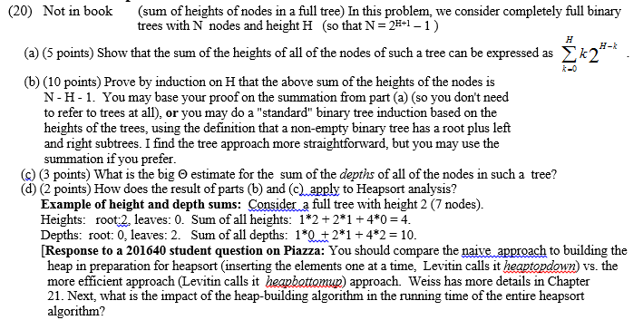
Problem 2 6.4.2 (6)
Assume a max heap.
Author's hint:
Problem 3 6.4.6 (15) PQ implementations
present your answer as a table whose columns are the five implementations
(in the order given) and whose rows are findmax, deletemax, insert, (in that order).
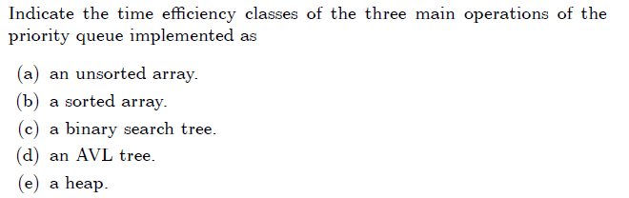
Author's hint:
Is totally useless. It just re3states the problem.

Problem 4 6.4.12 [6.4.11] (10)
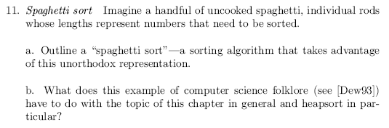
Author's hint:
Problem 5 6.5.10 [6.5.9] (4)
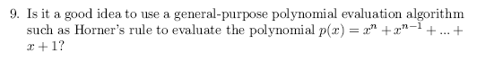
Author's hint:
Problem 6 7.1.6 (10)
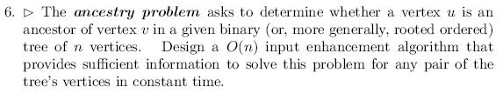
Author's hint:
Instructor notes
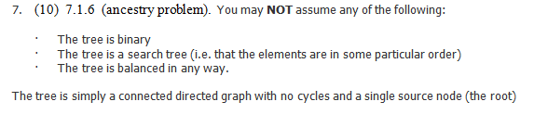
Problem 7 Not in textbook (15)
(tile grid with pluses and minuses)
For what values of n can we fill an n-by-n grid with + and – signs, such that each square has exactly one neighbor of the opposite sign? A neighbor is an adjacent square that is in the same row or column. Hint: Try to solve the puzzle for n=2, n=3, n=4.
For all “valid” n, show (or describe) all the ways of tiling the grid. For “invalid” n, show that it cannot be done.
Mathematical induction is necessary here.

