473 Levitin problems and hints HW 09A

Problems 1 and 2 are not from the textbook. Both are about NIM.
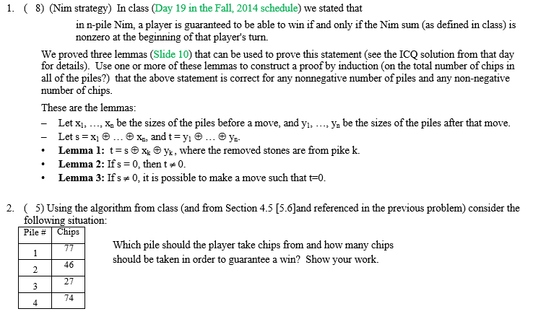
Problem 3: 4.4.8 [5.5.2] Ternary Search
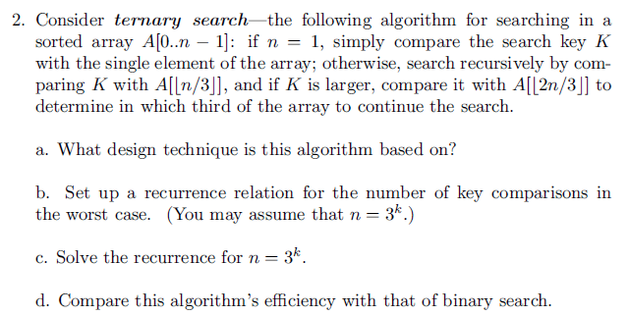
Author's Hints:
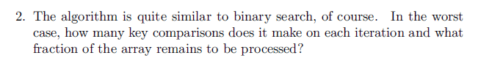

Problem 4: 4.4.10[5.5.3] fake coin divide into three
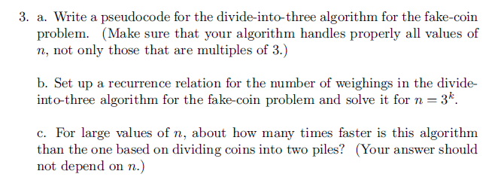
Author's Hints:

