473 Levitin problems and hints HW 08

Problem 1: (15) 5.3.8 [4.4.7]
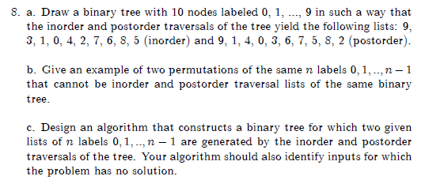
Author's Hints:
Details that I gave on the assignment page:

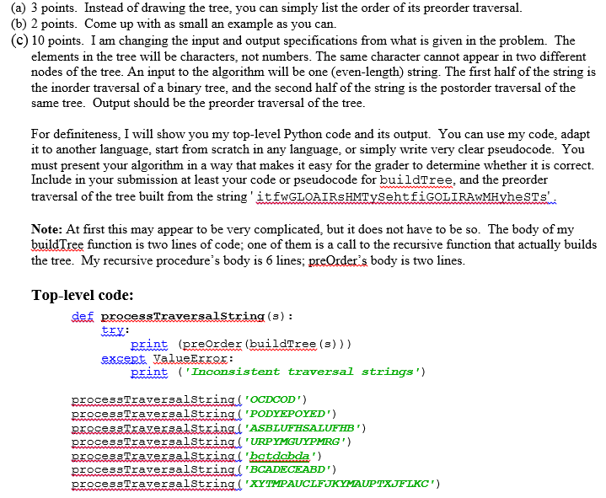

Problem 2: (5) 5.3.11 [4.4.10]
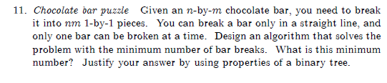
Author's Hints:

Problem 3: (5) 5.4.9 [4.5.9]
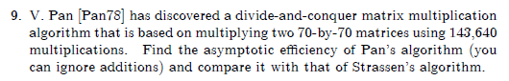
Author's Hints:
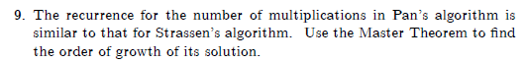

Problem 4: (10) 5.5.3 [4.6.2]
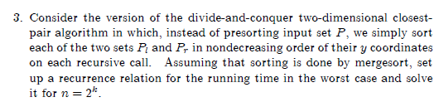
Author's Hints:
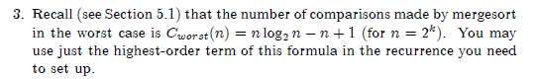

Problem 5: (5) 5.5.7 [4.6.6]
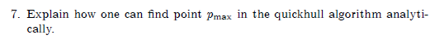
Author's Hints:
Problems 6-7: Not from textbook
6. ( 5) If the permutations of the numbers 0-7 are numbered from 0 to 8!-1,
what is the (lexicographic ordering) sequence number of the permutation 37246510?
Example sequence numbers: 01234567 has sequence number 0, 01234576 has sequence
number 1, 01234657 has sequence number 2, …, 76543210 has sequence number 8! - 1.
7. ( 5) Which permutation of 01234567 is number 25000 in lexicographic order?
Problem 8: (15) 2.4.6 [Not in 2nd ed.]
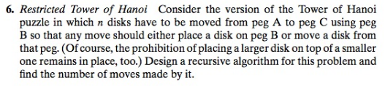
Author's Hints:
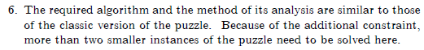
Problems 9-11: (5, 10, 6) 4.5.4-4.5.6 [5.6.4-5.6.6]
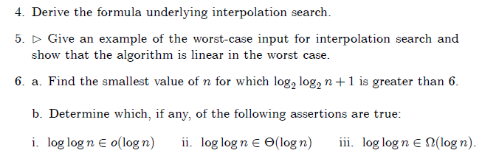

Author's Hints:
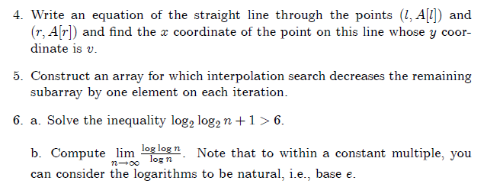

Claude's notes:

4.5.5 Show that the worst case is Θ(N)
4.5.6 For part b, use the "limit of the ratio" approach

