MA/CSSE 473 HW 6A Problem statements/hints

Problems 1-2 are related to Dasgupta pages 30-34 and Weiss section 7.4 (both on Moodle)

Problems 1 and 2 (copied here from the assignment document):
- (15) (RSA decoding). If small primes are used, it is computationally easy to "crack" RSA codes.
Suppose my public key is N=703, e= 53. You intercept an encrypted message intended for me, and the encrypted message is 361. What was the original message? How did you get the answer?
- (6) Find and read about various ways of attacking the RSA cryptosystem.
Write about two attacks that interest you. Write a paragraph about each one to explain in your
own words how it works.

Problems 3-7 relate to material that should be review from CSSE 230. In addition to the
Levitin textbook, Weiss Chapter 8 should be good background for those.
- Problem 3: (3) 5.1.4 [4.1.4] (logarithm base in Master theorem)
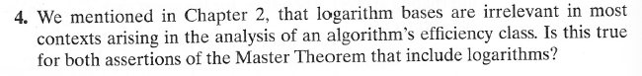
Problem 4: (6) 5.1.5 [4.1.5] (simple application of Master theorem)
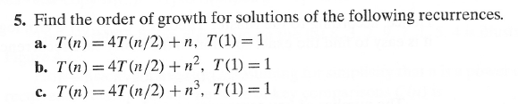
Author's hints for problems 3 and 4:
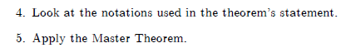
- Problem 5: (6) 5.2.2 [4.2.2] (Quicksort partition scan properties)
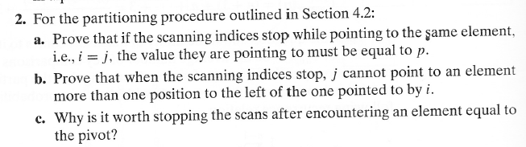
Author's hint for problem 5: Use the rules for stopping the scans.
Problem 6: (10)
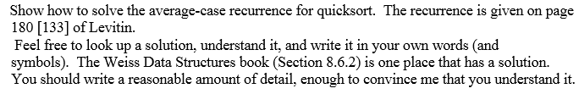

- Problem 7: (8) 5.2.11 [4.2.11] (Nuts and bolts). In addition to writing the algorithm,
write and solve a recurrence relation for average-case running time.

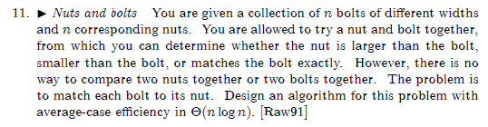
Author's Hints:
Use the partition idea that is part of QuickSort..

