473 HW 5 Levitin Problems
Problem 1: 3.2.3 (also see details in assignment document]
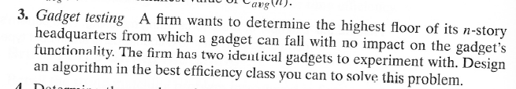
Let N be the total number of floors, and F the number of the lowest floor on which a
gadget fails when dropped from there.
Assume that due to weight, volatility, or some other factor, there is a high cost (C) for each floor that a gadget must be carried up. Also a cost (T) for each test to determine whether the drop caused the gadget to fail after each drop.
First, give big-Theta worst-case running times in terms of N, C, and T for the obvious algorithm that tries every floor in succession (that algorithm only requires one gadget). Then design and analyze the most efficient algorithm you can.
Can you think of any flaws in this general approach to testing?
Points: (Algorithm/analysis: 2, efficient algorithm/analysis: 10, flaw: 2)
Problem 2: 3.2.4
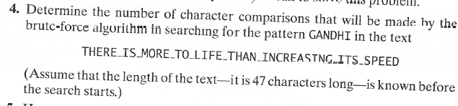
For any n and m, you are to give an example of strings of lengths n and m that lead to the worst case. I.e. your answer should be general, not an answer in which you choose a specific m and n. So you can't begin with something like
"Let m=7 and n=15"

Problem 3: 3.2.6
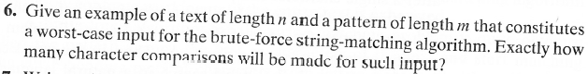
Problem 4: 3.3.4 [3.3.3]
Clarifications: (b) You can sketch or simply list them. Assume that all points have integer coordinates.
(c) By "a solution", they mean "an algorithm to solve the problem". Obviously Manhattan distance may give different nearest points than Euclidean distance. But here is the question you must answer: is the closest point algorithm itself the same for both?
Points: (a:5 , b:3, c:2).

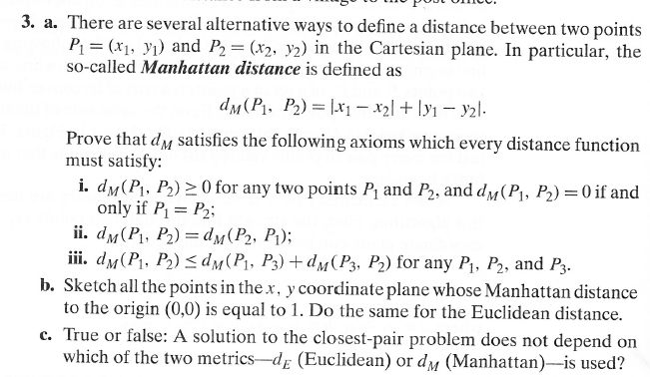
Problem 5: 3.3.7 [3.3.5]
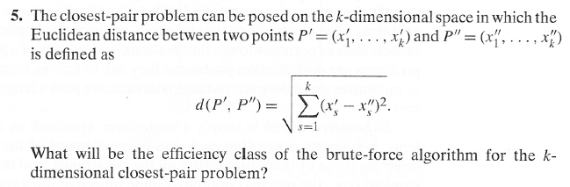
Problem 6: 3.3.10 [ 3.3.8]
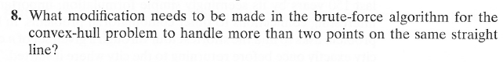
Problem 7: 3.4.1 (traveling salesman)
I told students that you can use either the 2nd or 3rd edition of the textbook. One says “one billion“ additions per second”; the other says “ten billion additions per second”. Use “one billion additions per second” when you do this problem.

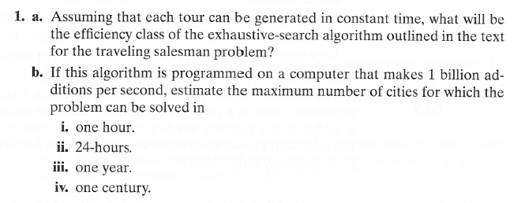
Problem 8: 3.4.5
Problem 9: 3.4.6
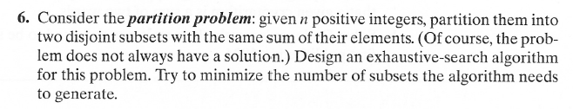
There is only so much a brute force algorithm can do to make this efficient.
Mainly, try to avoid checking duplicate subsets or subsets that cannot possibly be a solution.

Problem 10: 3.4.9 [not in 2nd edition]
The real question in each case is “if we make only the given restrictions, then check each possibility to see if it is a solution, how many possibilities will we need to check?” If we made no restrictions at all (not even the restriction that multiple queens cannot occupy the same square), then there would be 64⁸ placements to check. How many for each of the given cases?
