MA/CSSE 473 Day 22 Announcements and Summary
Announcements:
- HW9 due yesterday (with a grace day until tonight at 11:59 PM because of the break, no late days beyond that);
- HW 10 due Thursday.
- Exam 2 Tuesday Nov 4 in class
- No one told me about final exam conflicts, so I expect everyone to be there at the scheduled Monday evening time.
- In my office today: hours 6 and 8; some of that time I will be seeing my advisees..
Main ideas from today:
- A binary max heap is a complete binary tree with the additional property that …
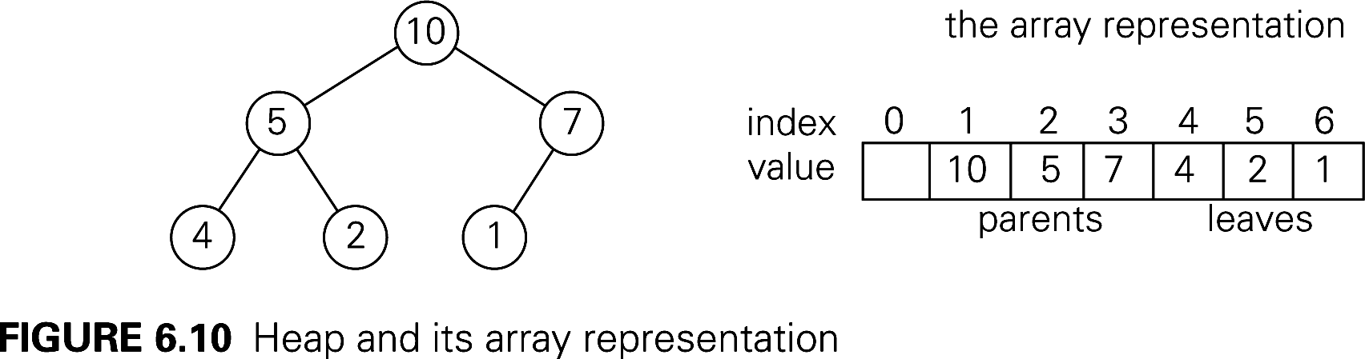
- Describe the details of the representation of a binary (max) heap by an array.
Runtime for insert and removeMax: (why?)

- Give a brief overview of how heapsort works.

- Next three questions: In a full binary heap (thus N is one less than a power of 2) represented as an array, let depth(i) be the depth of the node whose subscript in the array is i, and let height(i) be the height of the node whose subscript in the array is i.
- Give a simple formula (as a function of i) for depth(i).
- Show that the sum of the depths of all of the nodes in the tree is Θ (N log N).

- depth(i) + height(i) = _________________________
- Which is the faster of the two approaches for building the initial heap for HeapSort, and why?
- How can we use a “precalculation” with the adjacency matrix of a graph to count paths of length 2 in that graph?
- List several examples of algorithms where using additional space allows us to solve a problem faster.

