MA/CSSE 473 Day 21 Announcements and Summary
Announcements:
- HW9 due today (with a grace day until Tuesday because of the break, no late days beyond that);
- HW 10 due Thursday.
- Exam 2 Tuesday Nov 4 in class
- No one told me about final exam conflicts, so I expect everyone to be there at the scheduled Monday evening time.
- In my office today: hours 6, 8 and first half of 10.
Main ideas from today:
- Review a proof that the maximum height of a height-balanced tree with N nodes is Θ (log N):

- What property do all of the leaves in a 2-3 tree have?
- What are the upper and lower bounds on the height of a 2-3 tree with n elements?
- Continue the following sequence of 2-3 tree insertions by adding 10, 11, 12, …
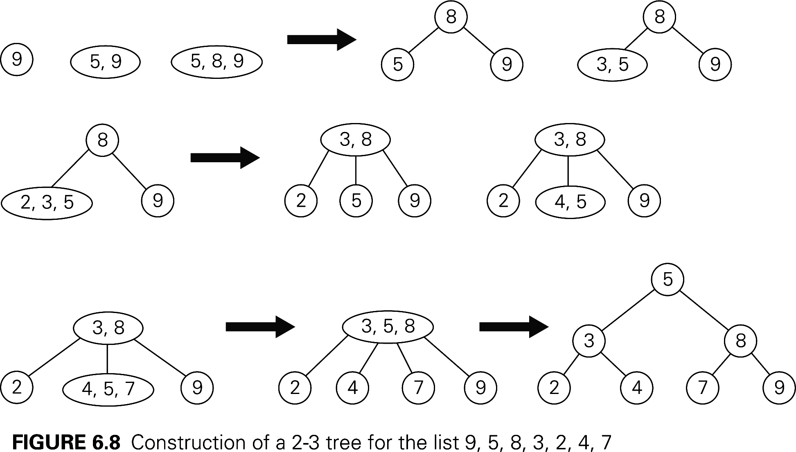

- Show the result of inserting 84 into this tree: 